SHOP 55 Health & Wellness Resource Guide
Ways to Stay Healthy & Well when Sheltering in Place
Compiled by SHOP 55 Wellness Center
www.shop55.org
Last Updated: Wednesday, March 25, 2020 at 1:49pm

This resource guide was translated in the languages below. Please note that when new resources are added, it may take some time for the translated version to be updated as well.
Spanish - Guía de recursos en español | Arabic:  عربي-ترجمة دليل الموارد هذا مستمر. يرجى التحقق مرة أخرى بانتظام. | Chinese - 中文資源指南

Greetings. The team at SHOP 55 Wellness Center hopes that you and your loved ones have been safe and healthy. SHOP 55 Wellness Center is a one-stop-shop for Oakland High’s students to get everything from first aid, counseling, mentoring, etc. As we are sheltering in place, we created this guide as a one-stop-shop for you to virtually access your essential needs AND how to take care of your whole self. This guide was designed for Oakland High Students, but can benefit anyone. Please share widely.

💛💗Tremendous appreciation to the various individuals and organizations that have showed up to support our youth and families during this time. Your resource may have been included in this guide. If there are changes OR you want to add additional resources here, please email rany@ebayc.org 💗💛

To Our Oakland High Students:
If you were receiving services at SHOP 55 Wellness Center, your Provider will be in contact with you to inform you whether or not services will continue via phone call or video chat. If you have not heard from your Provider yet, you may contact them directly. Here is a list of SHOP 55 Staff/ Partners & their Emails. If you need additional assistance getting in contact with your Provider or have questions/ need support, please contact SHOP 55 Wellness Center Director, Rany Ath, at rany@ebayc.org

To move through categories, you may click on the appropriate links below:
Emotional Support Services | Nutrition Services | Basic First Aid @ Home | Wellness Activities @ Home
Reproductive or Sexual Health Services | Staying Physically Active at Home | Resources for Undocumented Californians | Ways You or Others can Help
Financial Support to individuals affected by COVID-19 in California | Other suggested Activities to do during this time | SHOP 55 After School Program | Other Resources available to you and/or your family  - Tech Support  - Free comcast internet access for 60 days  - County Resources:  - Staying up-to-date with COVID-19

Other Helpful Resource Guides
OUSD Local Family Resources During School Closure  Available in: Spanish, Arabic, Chinese, and Khmer | Bay Area COVID-19 Mass Resource List from the Freedom Community Clinic

1. Emotional Support Services

Emotional Support Services | Contact Information
CA Peer-Run Warm Line: We are here for you 24/7!  Free live phone and chat support just a call or click away. | Phone: 1-855-845-7415  Chat via Instant Messaging (IM): Online. Click here to enter
Youth Suicide Prevention: Hours: 4:00 p.m. – 11:00 p.m. 7 days a week. Alameda County residents only  Fees: No charge from Crisis Support Services. Text STOP to opt out | Chat: Text the Word SAFE to 20121
Crisis Support Services of Alameda County, CA: 24 Hour Crisis Line. Callers do not have to be experiencing suicidal thoughts or feelings to call. | Phone: 1-800-309-2131
National Suicide Prevention Lifeline: We can all help prevent suicide. The Lifeline provides 24/7, free and confidential support for people in distress, prevention and crisis resources for you or your loved ones, and best practices for professionals. | Phone: 1-800-273-8255  Chat online: Click here to enter
SHOP 55 Check-In Service via phone or video. Only available to students who attend Oakland High School. Request for check in if you are in a non-life threatening situation, and would like to check in with someone from SHOP 55 Wellness Center. | Phone: 510-519-7098; If no pick up, please leave a message with your name and best time to call you back.  Request for phone/ video check in by emailing: Shop55oncall@gmail.com  Please include the following in your email:  Your full name, phone number, whether you prefer phone call or video, and best time(s) to call.

HELPFUL TIP: American Foundation for Suicide Prevention - Taking Care of Your Mental Health in the Face of Uncertainty

2. Nutrition services
OUSD has 12 sites that will be providing “Grab and Go” breakfast and lunch meals to ANY child under 18, free of charge. 3 days worth of meals will be distributed on Mondays, and 2 days worth of meals on Thursdays. Please note the following:
- Bring a grocery bag(s) or cooler to bring food home for the week.
- You can go to any of the 12 sites! Here is a map of where the schools are located.
- In addition to food, diapers, feminine hygiene products, and clorox will be given away (limited supplies).
- Caregivers can come in place of the student(s).
- If you are unable to pick up the meals yourself, we can arrange for food to be dropped off to you (Thanks to Kim Raney & Zum). Email your teacher OR rany@ebayc.org to put in a request. Note: This will only apply to families who have students who are immunocompromised and cannot be left at home or families where the primary caregiver is immunocompromised and you have cause to suspect another family member will not be able to access in-person OUSD food pickup.
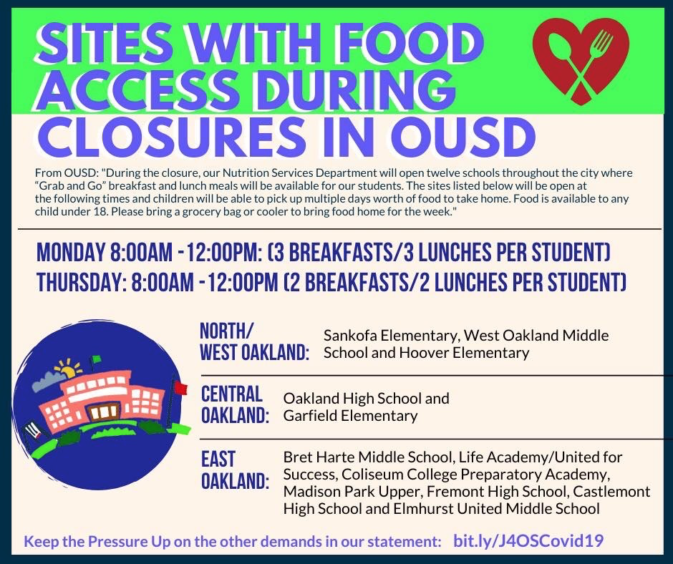
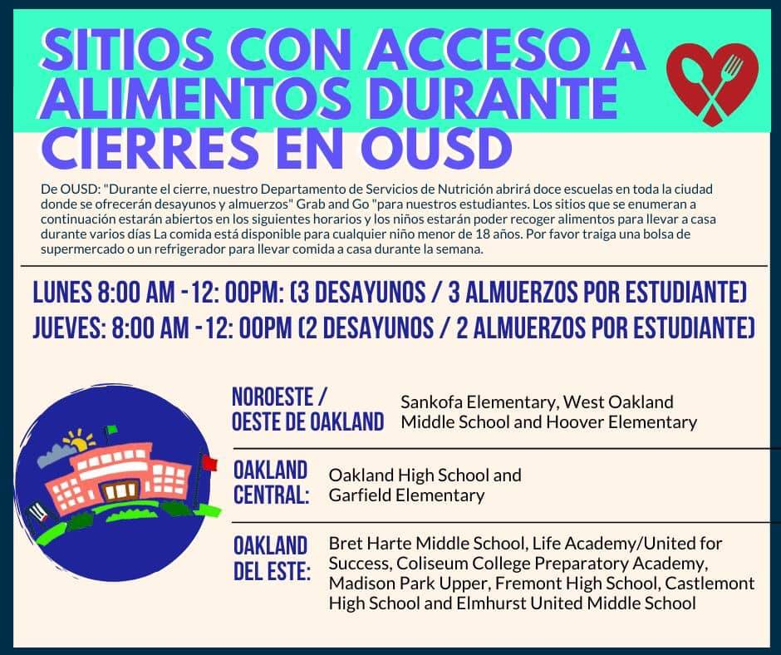

Another option for Free Grocery Delivery Service by Points of Light:
Points of Light will be delivering groceries to families with youth & children who do not have any means of transportation between the hours of 8:00am - 12:00pm.

Please call the designated youth director in your district:
District 1: (850) 532 - 2376
District 2: (510) 798 - 9240
District 3: (909) 800 - 2245
District 4: (909) 800 - 2245
District 5: (650) 720 - 1171
District 6: (510) 384 - 9032 OR (626) 272 - 4477
District 7: (786) 474 - 5600 OR (415) 283 - 9173

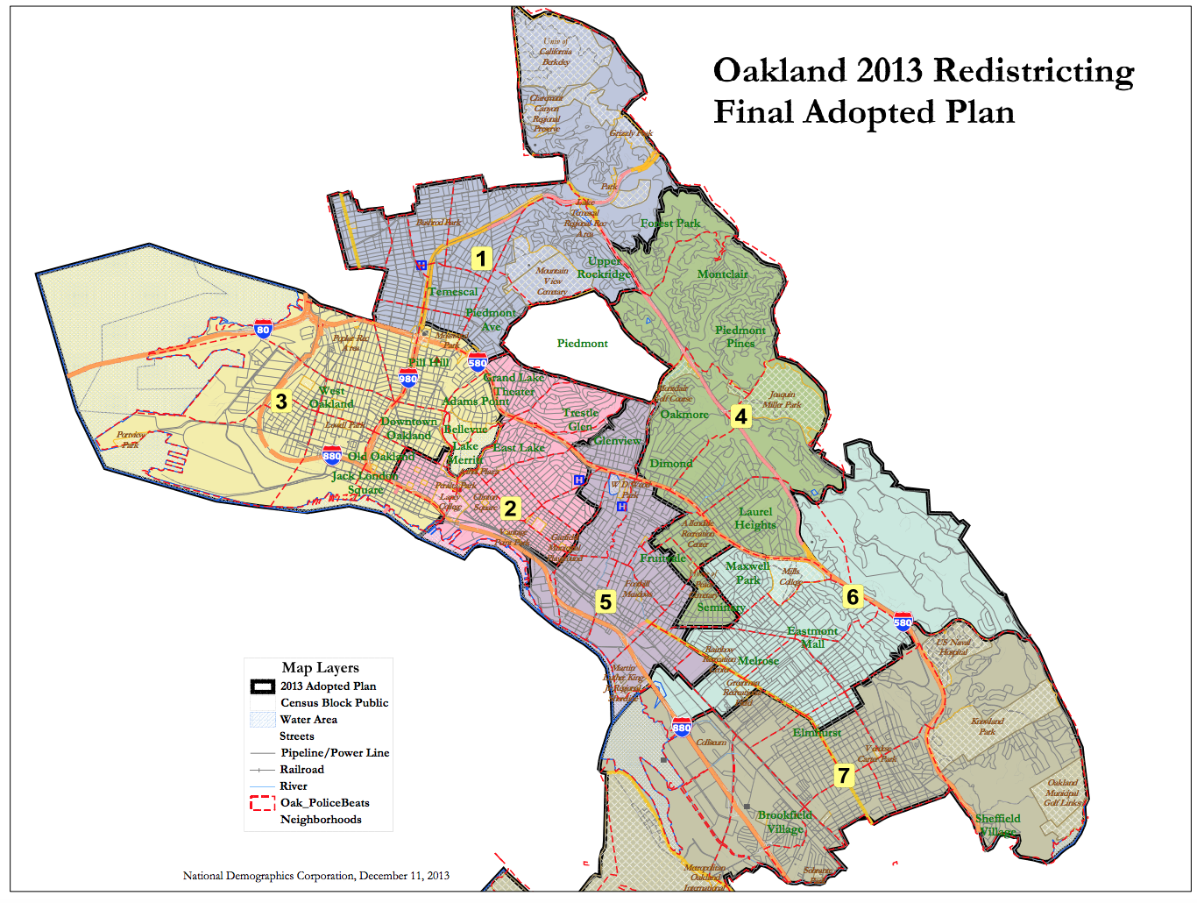
- You or your family may be eligible for Supplemental Nutrition Assistance Program (SNAP)
- If your family is in the Supplemental Nutrition Assistance Program (SNAP), your family is eligible for a new program with Expenisfy: matching SNAP grocery purchases of $50 per family.
- Purchase food as normal with your SNAP card
- Download Expensify on iOS or Android, for free
- Join the Expensify.org/hunger policy
- SmartScan the receipt, which will tell us how much you paid and show that it was paid for with an Electronic Benefits Transfer (EBT) card
- Submit it to volunteer@expensify.org
- Set up your bank account to receive the funds
- So long as we have funds available, we will reimburse up to $50 per family (one time), the very next day.
From the President of Exspenify.org: To be clear, we can't commit to reimbursing every single person in need — we have no idea how many people will do this, and unfortunately, we don't have unlimited funds. We also don't know how long this crisis will last and how far our brand new charity's resources will stretch[...].
- If you are or your family, or you know a family in Oakland, CA that needs groceries, please email info@oaklandtrybe.org. Oakland Trybe is hoping to support 200 families in Oakland!
- List of Alameda County food banks
- La SantaTorta Food Truck; 333 Broadway Oakland; Free hot meals 12-2p
- Oakland LGBTQ Community Center is providing food bags and hygiene kits until supplies run out. They are available for pick up Monday - Friday from 12pm - 5pm at 3207 Lakeshore Ave, Oakland, CA 94610. Please call if you have questions or to verify they still have supplies: 510-882-2286
HELPFUL TIP: Make sure to drink between half an ounce and an ounce of water for each pound you weigh, every day. For example, if you weigh 150 pounds, that would be 75 to 150 ounces of water a day (Note: There 8 ounces in 1 cup)

3. Basic First Aid at Home

****If you are in a life-threatening emergency, call 911 or go to the nearest emergency room.****

Have a Question for Your School Nurse?
¿Tiene alguna pregunta para la enfermera de su escuela?

Sherry Kassenbrock
Sherry.Kassenbrock@ousd.org
510.773.1760

We get over 25 visits of first aid daily at SHOP 55. To help you take care of your first aid needs at home, below is a symptom chart and suggested things to do at home:

SYMPTOM | WHAT YOU CAN DO
Headache | Drink more water or try tea. Hydration is important.
Head Injury | Try ice. If you experience changes in your vision, headache that does not go away, numbness, tingliness, vomiting, drowsiness, call your hospital for advice prior to going in.
Stomach ache OR Cramps | If you haven’t, try eating or drinking water or tea and/or use a heating pad. You can also make one by using a NEW, clean long sock OR sew any clean unused fabric together, put uncooked rice inside, tie in a knot and heat up in your microwave (30 seconds at a time to avoid burning). Once it’s warm, use for 10 minutes at a time and reheat as needed. Please do not leave on your body until burning pain or numbness.
Minor cut OR Scrape | Rinse with soap and water, pat dry and put bandaid(s) on as needed.
Bloody nose: | Apply pressure by using your index finger and thumb placing them on the sides of your nose (between your eyes), bleeding should stop 10-15 mins. Use ice for your forehead, top of your head or back of your neck.
Injury | - Try heating pad or Try RICE ( Rest, Ice, Compression, and Elevation)  - When using ice packs, make sure to cover with a paper towel prior to use to avoid skin burns. Use 10 minutes at a time. Do not leave until numbness. If pain worse, stop using.

Note: If you have tried these and any symptoms last longer than usual or worsen, seek further medical attention by calling your advice nurse or call 9-1-1.

Worsening symptoms may include, but not limited to:
o Extremely difficult breathing
o Bluish lips or tongue or face
o Persistent pain or pressure in the chest
o Severe persistent dizziness or lightheadedness
o New confusion, or inability to arouse
o New seizure or seizures that won’t stop

Advice Nurse Hotline by Health Network:
- Medi-CAL (i.e. Alameda Alliance): 1(866) 778-8873
- Kaiser: 1(866) 454-8855
- Blue Shield of California: 1(877) 304-0504
- Anthem Blue Cross: 1(800) 224-0336

If you are a patient of La Clinica, you can call their Consult Line on Monday- Friday from 8:30am - 5:00pm - (510) 481-4566

Not sure if you have MediCal? Have your caregiver call Alameda County Social Services at 1(800) 698-1118

Don’t have a doctor or medical Provider?
For adults and preschool aged children (ages 0-3) who do not already have a doctor or medical provider please call, La Clínica de La Raza - Transit Village at Fruitvale BART Station: 510-535-3650 OR San Antonio Neighborhood Health Center at 1030 International: 510-238-5462. | For OUSD students and school-aged children who do not have a doctor or medical provider, please call 510-481-4566 to be registered and triaged through Youth Heart Health Center (La Escuelita/Metwest Campus) or Hawthorne Health Center (WORLD/ACHIEVE Campus).
Note about Public Charge: If families are concerned that the Public Charge Rule may affect their immigration case if they access medical care, please mention this when you call to register. Public Charge Rule does not apply to individuals under 21 (age 20 and below).

Are you currently experiencing cough, fever, or shortness of breath?
- If Yes:
  - Stay home until you get further medical advice.
  - Do you know your Primary Care Provider?
    - If Yes > Please call your Primary Care Provider for medical advice.
    - If No > If you do not know your Primary Care Provider please call your advice nurse.

HELPFUL TIP: Practice Healthy Hygiene. This includes:
- Wash your hands
- If you have long and or fake nails, make sure to clean the top and bottom of your nails using antibacterial soap.
- Clip and groom fingernails and toenails weekly
- Avoid touching your face, especially your eyes, nose, and mouth.
- Shower or bathe daily. Clean your body and wash your hair.
- Brush your teeth twice a day and preferably floss daily
- Use personal hygiene such as deodorant or antiperspirant as needed
- Wear clean clothes and socks. Change under clothes daily
- Don’t share makeup

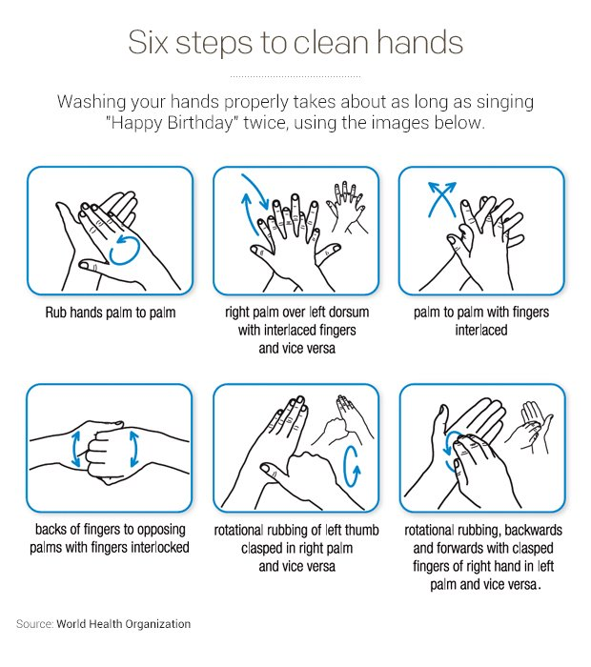

Video: Washing hands… the #1 way to stop the spread and lower the curve

4. Wellness Activities you can do at home: We encourage you to include one or more wellness activities during your daily routine. Below are some ideas:
- Mindfulness Activity: Why Mindfulness?: Why Mindfulness Is a Superpower: An Animation
  - Apps you can download for free:
    - Headspace - Available for download on Android and iOS
    - Calm - Available for download on Android and iOS
    - Aura - Available for download on Android and iOS
    - Stop, Breathe & Think - Available for download on Android and iOS
    - Insight Timer - Available for download on Android and iOS
  - YouTube Guided Videos
    - 10 minutes of Mindfulness Meditation
    - Body Scan Meditation
    - Mindfulness Exercises - One Simple Mindfulness Exercise
    - Search “Mindfulness Exercise” on YouTube and find what works for you!
- Do nothing for 5 minutes: Read the benefits of doing this
- Journal/ Writing: Free write with what you are feeling, seeing, and/ hearing OR choose from the below prompts:
  - How would I like to feel today?
  - What do I need right now?
  - Who are the people in my life who are nonjudgmental, trustworthy and genuinely have my heart in mind?
  - What is one healthy thing I can do to support myself when I’m sad or stressed out?
  - What are several physical activities that I actually enjoy?
  - What is one story that doesn’t support me, which I can reinterpret?
  - What is one feeling I’ve been having a hard time feeling?
  - What makes my heart sing?
  - What would I say to someone I deeply care about who was struggling with the same issue I am?
  - What is stopping me from being kind to myself?
  - If I loved myself fully, how would I treat myself every day?
  - What’s a lesson I can learn from a recent mistake?
- Do it Yourself (DIY) Stress reliever tools (Note: you’ll need certain supplies, but you can get creative as well!)
  - Stress Ball
  - Calming Glitter
  - 6 DIY Fidget Toys With Common Household Items
- Stress reducing coloring sheet:
  - Here are tons of stress relieving coloring sheets. You can print or color online. Don’t have a printer? Trace from your computer screen and color OR draw it out! (We got to get creative with what we have!)
- Create a playlist or identify songs that bring you joy or peace
  - You can create a playlist of videos on Youtube
  - Free music streaming (Will require you to sign up)
    - Pandora
    - IHeart Radio
- Take a shower, the action may feel like “washing the stress away.”
- Breathing exercises:
  - Breathe to the movement of this image
  - Deep Belly Breathing
  - Mindful Breathing - YouTube Video
- Find an inspirational quote, print or write on paper to post in your room or save as a screensaver on your phone or computer!
- Draw or color! Find an object or landscape (real or imaginary) and draw/ color your heart out!
  - Free Mandalas
  - Free coloring pages
- Video chat with your friend(s) or family! Seeing the people we care for may bring us joy and peace.
- Cook a meal or Bake! Find tons of free recipes online OR find sites/app that lets you put in ingredients you do have and they will suggest a recipe for you (i.e. Supercook)! (Take a picture & share on social media OR create an album on your phone).
- Continue to practice compassion for yourself and others, even virtually.

4. Reproductive or Sexual health
If you received reproductive or sexual health services with the SHOP 55 Clinic through Asian Health Services (AHS) and need an appointment or have questions, please call 510-418-5332 on Wednesdays from 8:30am - 4:30pm. You may call us during other times and leave a voicemail and we will get back to you as soon as possible.
In addition, below is a list of community clinics still open that will help you with your reproductive needs. Please call before you visit:
Youth UpRising @ Castlemont High School
8711 MacArthur Blvd. Suite A
(510) 428-3556

Hours
Mondays: 1:30-4:30p
Wednesdays: 1:30-4:30p
Fridays: 8:30-11:30a
Hawthorne Health Clinic
1700 28th Avenue
(510) 535-6440
Youth Heart Health Center
286 E10th Street
(510) 879-1568
Asian Health Services Teen Clinic
*Phone advice line only from M - F 11:00a-5:00p*
510 - 912 - 8598
Planned Parenthood
https://www.plannedparenthood.org/health-center

HELPFUL TIP: Download Healthy Oakland Teens App (Android or iOS) to view contact information for other clinics throughout Oakland. Call before you go as many are or may close in the coming days.
5. Staying Physically Healthy at Home

Try to get at least 30 minutes of physical activity, whether outside (if permits) or inside. Below are some ways to stay active inside:
- Free workout apps
  - 7 - Minute Workout - Available for download on Android and iOS
  - Search your app store for free workout!
- You tube videos of guided workouts:
  - 30 days of Yoga
  - Planet Fitness Home Work In - The workouts will be live-streamed at 7p.m. ET each day for the next two weeks (starting 3.17.2020)
  - Search “workout routines at home” or “workout routines without equipment”
Helpful Tip: In addition to being active, make sure you get a good night sleep! Teens should be getting at least 8 hours of sleep. Read: Sleep for Teenagers
6. Resources for Undocumented Californians
- CA Immigrant Youth Justice Alliance complied as list of resources for those who are undocumented: https://ciyja.org/covid19/
- Undocumented families who plan to apply for documentation in the future should still seek testing/treatment for COVID. COVID is public charge exempt. Read more here.
- On March 13, U.S. Customs and Immigration Services announced that testing, prevention, or treatment for COVID-19 will NOT be used against immigrants in a public charge test. This means that immigrant families should seek the care they need during this difficult time. Below is some information about the rights of immigrants’ rights in health care settings:
  - It is safe and smart to see the doctor if you need care. Your doctor is required to honor your right to privacy. You do not need to share any information about your immigration status unless you apply for Medicaid or other health coverage.
  - You can still see a doctor without medical insurance. This includes care you receive in the emergency room, at community and migrant health centers, free clinics, and public hospitals. If you don’t have a doctor, call a local community health center for assistance. You can find a health center here: https://findahealthcenter.hrsa.gov/
  - Hospitals and health care spaces are safe to visit. Federal guidelines prohibit immigration agents from conducting arrests or other enforcement actions at health care facilities, such as hospitals, doctors’ offices, health clinics, and urgent care facilities.
  - California residents can access Keep Your Benefits for more information about how their use of public benefits may effect their documentation status. Informed Immigrant also provides resources and accurate information for immigrant families with questions about their benefits.
  - CLICK HERE to learn more about your rights when accessing health services.
- If you feel your rights or the rights of someone you know have been violated, you can file an immigration enforcement civil rights complaint. To learn more about filing a complaint, click here.
- Financial support Service Worker - Make sure you review Frequently Asked Questions - Note: Undocumented Service Workers are elgilble and encouraged to apply! - In Spanish: https://ofwemergencyfund.org/ayuda
- COVID-19 Resources for Undocumented Communities - Resources nationwide and by state

7. Ways You or Others can Help

- Volunteer with the East Bay Mutual Aid: East Bay Mutual Aid - Services and Needs
- Text or call your friends, family, or neighbors to see if they need assistance, especially those vulnerable to contracting COVID-19 -- elders and those with underlying health conditions (i.e. diabetes, cancer, etc.)
- If you know someone that is 65 or older, below are some resources to help them:
- East Oakland Collective is offering supplies and food for seniors, unhoused folks, people with compromised immune systems. Please contact EOC for availability of supplies and food at 510-990-0775 or info@eastoaklandcollective.com https://www.instagram.com/p/B9zMHKrhAgn/
- San Francisco and Oakland: Project Open Hand still serving and delivering meals
https://www.openhand.org
- Safety for Survivors of Violence
  - A huge list of Bay Area resources from Leap SF addressing family violence including reporting lines for abuse, crisis intervention, crisis shelters, counseling resources/referrals, legal resources: https://www.leapsf.org/pdf/family-violence-resources.pdf

7. Financial Support to individuals affected by COVID-19 in California
- Scholly COVID-19 Student Relief Fund - Students can apply to receive $200 in cash assistance to help cover expenses during this global crisis. After reviewing your application, you may be selected to do a phone OR video interview. Shortly after, you will be informed on whether or not you were awarded the relief fund. Application closes on June 15, 2020 at 11:59pm. Make sure you read Terms & Conditions before you apply. NOTE: Undocumented students not elglible.
- Financial support Service Worker - Make sure you review Frequently Asked Questions - Note: Undocumented Service Workers are elgilble and encouraged to apply!
- Benefit Summary for Workers impacted by COVID-19
- The Employment Development Department (EDD) is offering financial support to those affected by COVID-19. To see if you or a household member qualifies visit: https://edd.ca.gov/about_edd/coronavirus-2019.htm
  - Examples for those who qualify:
    - You can’t work because your employment shut down OR reduced your hours through no fault of your own.
    - You can't work because you've been diagnosed and have to be hospitalized or quarantined.
    - You can't work because you have to take care of a family member who has been diagnosed.
HELPFUL TIPS:
- OLSE Advice Line has Attorneys and Navigation Managers who can help workers determine eligibility and apply for benefits. Call: 1(866) 870-7725
- FAQs on Sick Leave COVID-19 in CA

8. Other suggested Activities to do during this time

- Set a daily schedule OR create a check list of things you want to accomplish each day
- Ask your Caregiver to complete the 2020 Census for your household by April 1, 2020!!!
  - Video: What is the Census?
  - Slide Deck: Census Overview by EBAYC
  - Frequently Asked Questions
- Read! Read! Read! Knowledge is power! Access the Oakland Public Library Online
- Over 30 virtual field trips!
- 150+ Educational shows on Netflix
- 15 Broadway Plays and Musicals You Can Watch On Stage From Home
- If you have younger siblings to take care of:
  - Scholastic is offering 20 days of exciting articles and stories, videos, and fun learning challenges!
  - Giant list of ideas for being home with the kids

9. SHOP 55 After School Program
- We're here for you! Join SWAG every Tuesday and Thursday from 2-3p for homework help, games and community! Academic Mentors will be there to help you with your assignments, play games if you're feeling bored, or talk about anything you want. Just click here: https://ousd.zoom.us/j/187481543 either on Tuesday or Thursday at 2pm. Hope to see you there!

HELPFUL TIP: Consider joining one of the many after school program offerings we have at Oakland High School! We have everything from homework help, mentoring, music studio, and paid internships! Get a glimpse of what we have to offer by viewing our SHOP 55 After School Program Spring Schedule

10. Other Resources available to you and/or your family

Tech Support
- If you are an Oakland High student, and do NOT have a computer or laptop at home, please email an Oakland High teacher or rany@ebayc.org. The Admin team at Oakland High is gathering a list of students that may need to borrow a Chromebook so you can continue your education virtually. If you are on the list, you will get a call from an OHS staff to schedule a day/time for you to check out a chromebook & charger. See “Internet Access” below to get free wifi.

Internet Access
- Comcast offering Free internet for 60 days: https://www.internetessentials.com/
  - Comcast is currently offering low-income families 60 days of complimentary Internet Essentials service for new subscribers. This service is normally $9.95 a month.
  - Comcast is also making Xfinity WiFi hotspots free throughout Oakland. For a map of these hotspots, visit www.xfinity.com/wifi. Once at a hotspot, select the “xfinitywifi” network name in the list of available hotspots. More information is available at https://corporate.comcast.com/covid-19.
- Access from AT&T - Discount Internet Access: 60 days free service, $10/month after - Phone:855-220-5211
- Access from Sonic - Discount Internet Access + Home Phone - three months free service, $40/month after - Phone: (888) 766-4233

County Resources
- Alameda County Resource Guide
- Alameda County Social Services Agency: To ensure the health and safety of clients, staff, and the community at large, Alameda County Social Services Agency is encouraging clients who are receiving or wish to apply for Medi-Cal, CalFresh, CalWorks, Welfare-to-Work, Refugee Cash Assistance, and General Assistance to use the telephone, mail, and online services that are currently available. Full notice available in various languages here.

Staying Up-to-date with COVID-19
- OUSD All City Student Union hosted a Live session on Student Health & Wellness - Check out the recorded version: Presentation, Q&A, Slidedeck
- OUSD updates visit: https://www.ousd.org/coronavirus
- Get updated info on coronavirus in Alameda County here or visit the CDC for updated info and FAQs.
- California COVID-19 resource guide - https://docs.google.com/document/d/1y7amzzVkKP4tqp-CnKr7zeKnzk3tfRLpzReWPFgdNDI/mobilebasic
- The California Endowment created a downloadable fact sheet, proper hygiene precautions poster, and a Stop! Poster in various languages. To view, download, and print/share visit: COVID-19 Resources for Partners
- Information on COVID-19 in Mam provided by OEA
- Coronavirus: Multilingual Resources for Schools
- The Vox guide to Covid-19 coronavirus
- Hope
  - Article - Coronavirus recovers in South Korea Outnumber new Cases for First Time Since Outbreak Began
  - Article - Coronavirus: 1g03-year-old woman becomes oldest person to beat disease
  - Facebook Video - Daniel Kim’s experience fight COVID-19
- Hear from others around the world with their experience to COVID-19
  - Article - 'Don't panic' says US woman who recovered from coronavirus
  - Video - Italians who were quarantine send video message to themselves
  - Article - 8ight Things I learned in Solitary Confinement, That Will Help You Keep Calm During the Coronavirus Pandemic
- Article - Food Safety and Coronavirus: A Comprehensive Guide
- Asian and American Pacific Islander For Civic Empowerment-Education Fund has COVID-19 information available in English, Hmong, Marshallese, Traditional Chinese, Simplified Chinese, Vietnamese, Korean, Tagalog, Cambodian, and Japanese. See bottom of article: Community Care During COVID-19: A message to and from AAPIs
