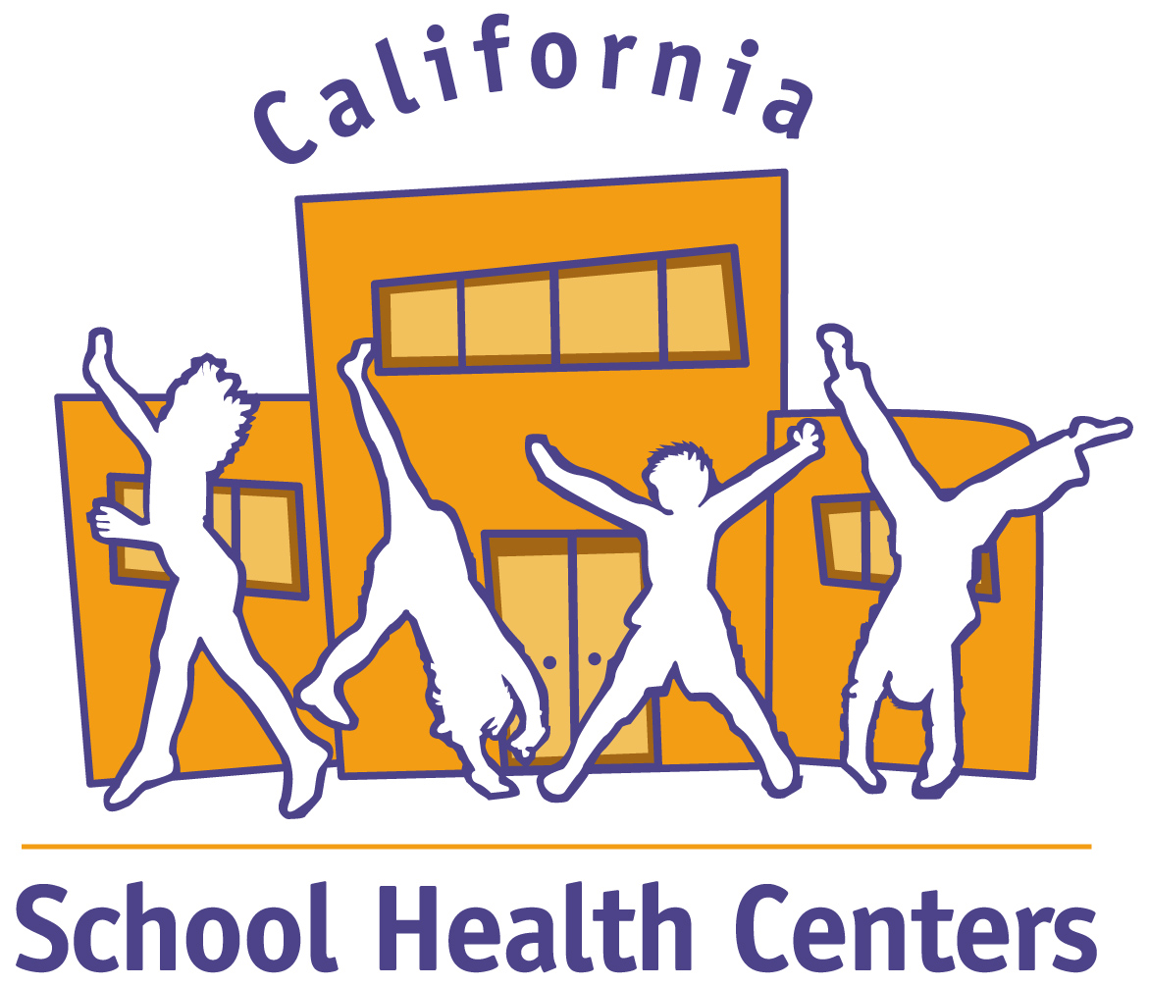 | California School Health Centers Association  2011-2012 Members & Donors

Advocates for Student Success

Check Point Software Securities Inc. | Serena Clayton*
Los Angeles County Education Foundation | Joanie & Jesse Rothstein
St. John’s Well Child & Family Center | Max & Mary Diane Stites
The Capital Group Companies Charitable Foundation | Kimberly Uyeda
Larry Aceves | Dexter Webster
Raymond Clayton

Champions for Healthy Kids

Center for Oral Health
Clinica Sierra Vista
James Morehouse Project
Providence Little Co. of Mary
Riverbank USD
Kristin Andersen
Selina Escobar
Ken Geisick
Merry Ann Grasska
Jan Marquard-Tormey
Mike Miller
Judy Silva

Organizations

A Better Way
Adventist Health
Alameda County Health Care Services Agency*
Alameda Family Services*
Asian Health Services*
Balboa Teen Health Center
Bay Area Community Resources
Bienvenidos
Cal Healthcare & Education Reform
California Pan-Ethnic Health Network*
California Primary Care Association
Castle Family Health Center
Child and Family Guidance Center
The Children’s Clinic
Children’s Hospital and Research Center Oakland*
City of Berkeley*
Community Clinic Assn of LA County
Contra Costa County Health Services
East Bay Agency for Children
East Bay Asian Youth Center*
East Valley Community Health Center
Eisner Pediatric/Family Medical Center
Family Health Centers of San Diego
Foothill Community Health Center
Fresno County Office of Education
GlaxoSmithKline
Golden Valley Health Centers
Green Dot Public Schools
Hatchuel Tabernik & Associates, Inc.*
Health Net of California
Healthy Connections, Inc.
Kids Come First Community Clinic
Kings Canyon Unified School District
Korean Health Education Information & Referral Center
La Clínica de La Raza*
La Maestra Community Health Centers
Lake County Office of Education
LifeLong Medical Care*
Lincoln High School
Los Angeles Trust for Children’s Health
Los Angeles Unified School District
Mendocino Community Health Clinic
Mission City Community Network
Native American Health Center*
Northeast Valley Health Corporation
Novato Youth Center*
Oakland Unified School District
Operation Samahan Inc.
Pacific Health Consulting Group*
Planned Parenthood Pasadena & San Gabriel Valley
The Saban Free Clinic
Sacramento City Unified School District
Salud Para La Gente
San Geronimo Valley Community Center
San Leandro Unified School District
School Health Clinics of Santa Clara
South Central Family Health Center
Tahoe Truckee USD
T.H.E. Clinic, Inc.
Tiburcio Vasquez Health Center, Inc.*
Tuolumne County Office of Education
Tulare Community Health Clinic
UMMA Community Clinic
Vacaville Unified School District
Vallejo City Unified School District
Valley Community Clinic
Valley Health Team
Ventura Unified School District
West Contra Costa USD
YMCA of the East Bay

Individuals

Roberta Bavin
Laura Baynham
Eileen Blumenthal
Claire Brindis
Wilma Chan
Elizabeth Chicoine/Mark Sloan
Joel Cohen
Mark Cooper
Denette Davis
Brent Dupper
Joseph Eichenseher
Bonnie Folkes
Linda Garrett
Michael A. Godfrey
Laura Hogan
Angela Jenkins*
Debra Johnston
Sandra Jones
Pamela Kahn
Zettie Page III
Martha Quesada-Beckner
Ann Rector
Audrey Scott
Judy Sencenbaugh
Mike Spence
Deanna Staggs
Regie Stites
Sang Leng Trieu

2011-2012 Major Funders

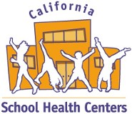
Blue Shield of California Foundation
The California Endowment
Kaiser Permanente
S.D. Bechtel, Jr. Foundation
The California Wellness Foundation
The San Francisco Foundation
National Assembly on School Based Health Care

Corporate Partners

CompuMed
Dairy Council of California

2012 Conference Sponsors

GOLD
Blue Shield of California Foundation
Kaiser Permanente

SILVER
The California HealthCare Foundation
The California Endowment
Health Net

BRONZE
Alameda County Health Care Services Agency
California Association of Health Plans
Los Angeles County Education Foundation
Los Angeles Trust for Children’s Health
Lucile Packard Foundation for Children’s Health
Paradigm Healthcare Services

EXHIBITOR

Calif. Dept. of Alcohol and Drug Prevention
Dairy Council of California
ETR Associates
Genzyme Corp.
Hemocue
Kognito Interactive
MedImmune
Plak Smacker
Sanofi Pasteur
School Health Corporation
SyTech Solutions
Welch Allyn, Inc.

