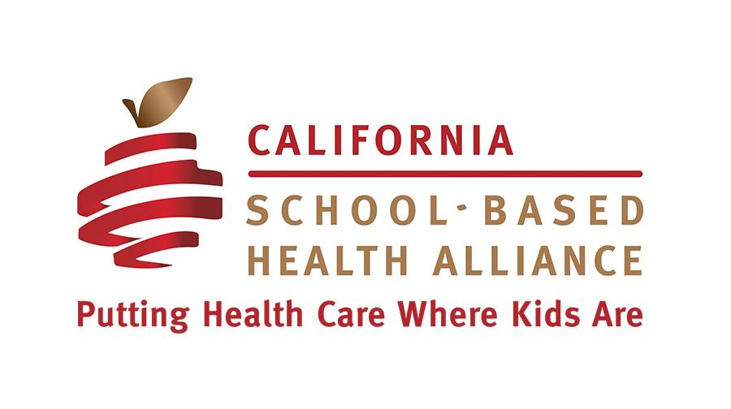
Request for Proposals for 2015-2016
Tobacco Prevention Peer Education Project
Due Friday, June 12, 2015 at 5pm

Opportunity
After years of leading the nation in youth tobacco prevention, California’s efforts have waned in recent years. Yet tobacco use continues to be a leading cause of death. Tobacco use is best prevented during adolescence and school-based health centers (SBHCs) should be on the forefront of tobacco prevention in their school communities.

The California School-Based Health Alliance (CSHA), in partnership with the CVS Health Foundation and the Campaign for Tobacco-Free Kids, is launching a new initiative to reinvigorate school-based tobacco prevention through SBHCs. We are seeking five SBHCs to engage youth in tobacco prevention peer education.

SBHCs in this project will receive a high level of support from CSHA, including training and webinars on how to run effective tobacco peer education programs. Tools, resources, and ongoing technical assistance will be provided to SBHCs to support successful implementation of the project.

Timeline
Applications due: June 12, 2015
Awardees notified: June 26, 2015
Project timeframe: August, 2015 - May, 2016

Eligibility/Selection Criteria
- SBHCs must be in California but cannot be in Los Angeles County.
- Wellness centers, school-linked, or mobile programs are eligible.
- Applicants should be able to partner with their school administrators to implement schoolwide projects.
- Priority will be given to applicants that are members of the California School-Based Health Alliance.

Participation Requirements:
The project represents a youth-led approach to tobacco prevention education. Participants will be expected to:
- Select at least two SBHC staff to participate in one all-day training in Oakland, CA, and four webinars on running effective tobacco peer education programs using positive youth development principles. (Travel costs for training will be covered by CSHA.)
- Train 25 students as peer educators to advocate for youth tobacco prevention strategies.
- Work with peer educators to accomplish the following activities:
  - Conduct a schoolwide tobacco needs assessment and develop a schoolwide tobacco education and awareness campaign that includes locally developed messages.
  - Provide tobacco prevention education and/or cessation information to at least 400 students.
  - Lead a schoolwide Kick Butts Day event on March 16, 2016.
- Participate in program evaluation including surveys of SBHC staff and peer educators.
- Document tobacco peer education activities through photos, videos, social media, and youth testimony to co-develop develop success stories with CSHA.
Tools and resources will be provided to participants to ensure achievement of program deliverables.

SBHC Sponsor Agency Expectations:
- Approve all leave and travel associated with the project for SBHC staff.
- Approve all project related work described above.

Payment:
Selected sites will receive a stipend of $5,000 to cover staff or consultant costs, supplies for educational campaigns or Kick Butts Day event, and food or facilities for youth peer educator meetings. Travel expenses for the all-day staff training will be covered by CSHA and do not need to be included in the project budget. Payments will be made based on completion of project activities as follows:
First payment --$2,000 completion of staff and student training
Third payment -- $3,000 upon completion of Kick Butts Day event

For more information contact:
Janine Y. Saunders, MPH
Senior Project Director
California School-Based Health Alliance
jsaunders@schoolhealthcenters.org

Applications are due on June 12, 2015, by 5:00 pm
Please submit applications to jsaunders@schoolhealthcenters.org

A. About the SBHC
Name of SBHC:
Date SBHC established:
SBHC Address:
Name of School:
School where SBHC is based is (BOLD all that apply): | Middle school  High school
Enrollment at host school (#):
# SBHC patients: (This # should include all unique patients within a 1-year period)
SBHC operating hours:

B. About the SBHC sponsoring agency
Agency:
Type of organization (BOLD only one): | Community health center  FQHC  School district  Hospital | Non-profit organization  Other:
Chief Executive Officer: |  | Email
Fiscal Contact: |  | Email

C. About the participants (at least two participants are required)
Participant Name:
Title:
Years at SBHC:
Please describe your role at the SBHC in a few sentences:
Contact Email:
Contact Phone #:

Participant Name:
Title:
Years at SBHC:
Please describe your role at the SBHC in a few sentences:
Contact Email:
Contact Phone #:

Insert additional participant information, if necessary

D. Project Description
Please describe your SBHC’s experience with peer education and/or tobacco prevention education programs. Please limit your answer to 400 words or less

Please describe your SBHC’s capacity (both systems and staffing) to recruit and train student peer educators. Please limit your answer to 400 words or less

Please describe the SBHCs relationship with school and/or district staff and administration, including school nurses. How well do you work together? Are communication structures in place? How integrated is the SBHC into the school (e.g. does the SBHC host campus wide events, participate in a wellness committee, train teachers, etc.)?
Please limit your answer to 400 words or less

Why are you interested in the Peer-Based Tobacco Prevention Education Project? What goals do you hope to achieve?
Please limit your answer to 400 words or less

