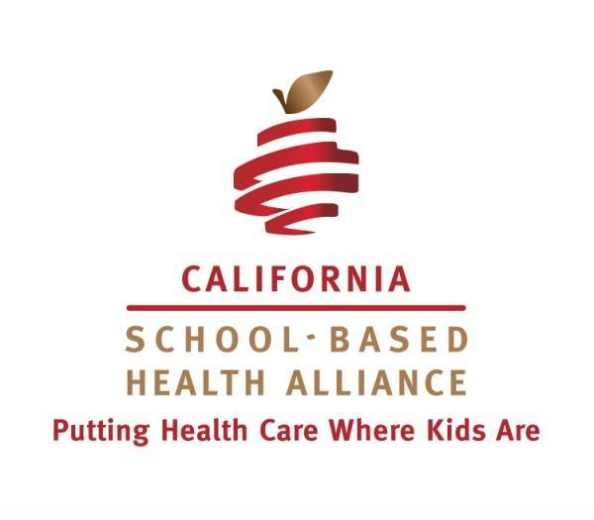
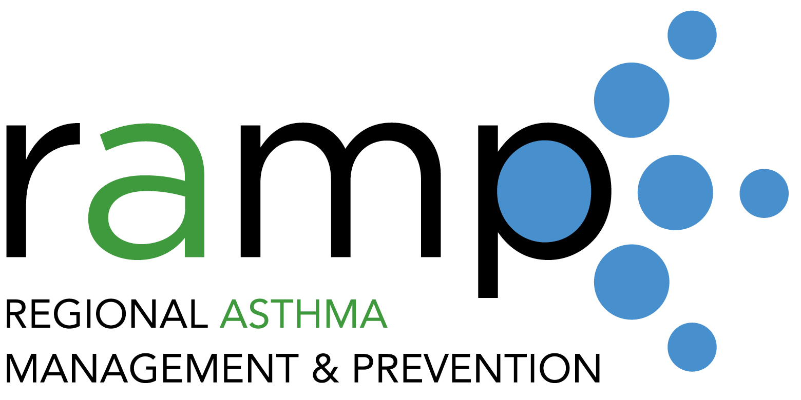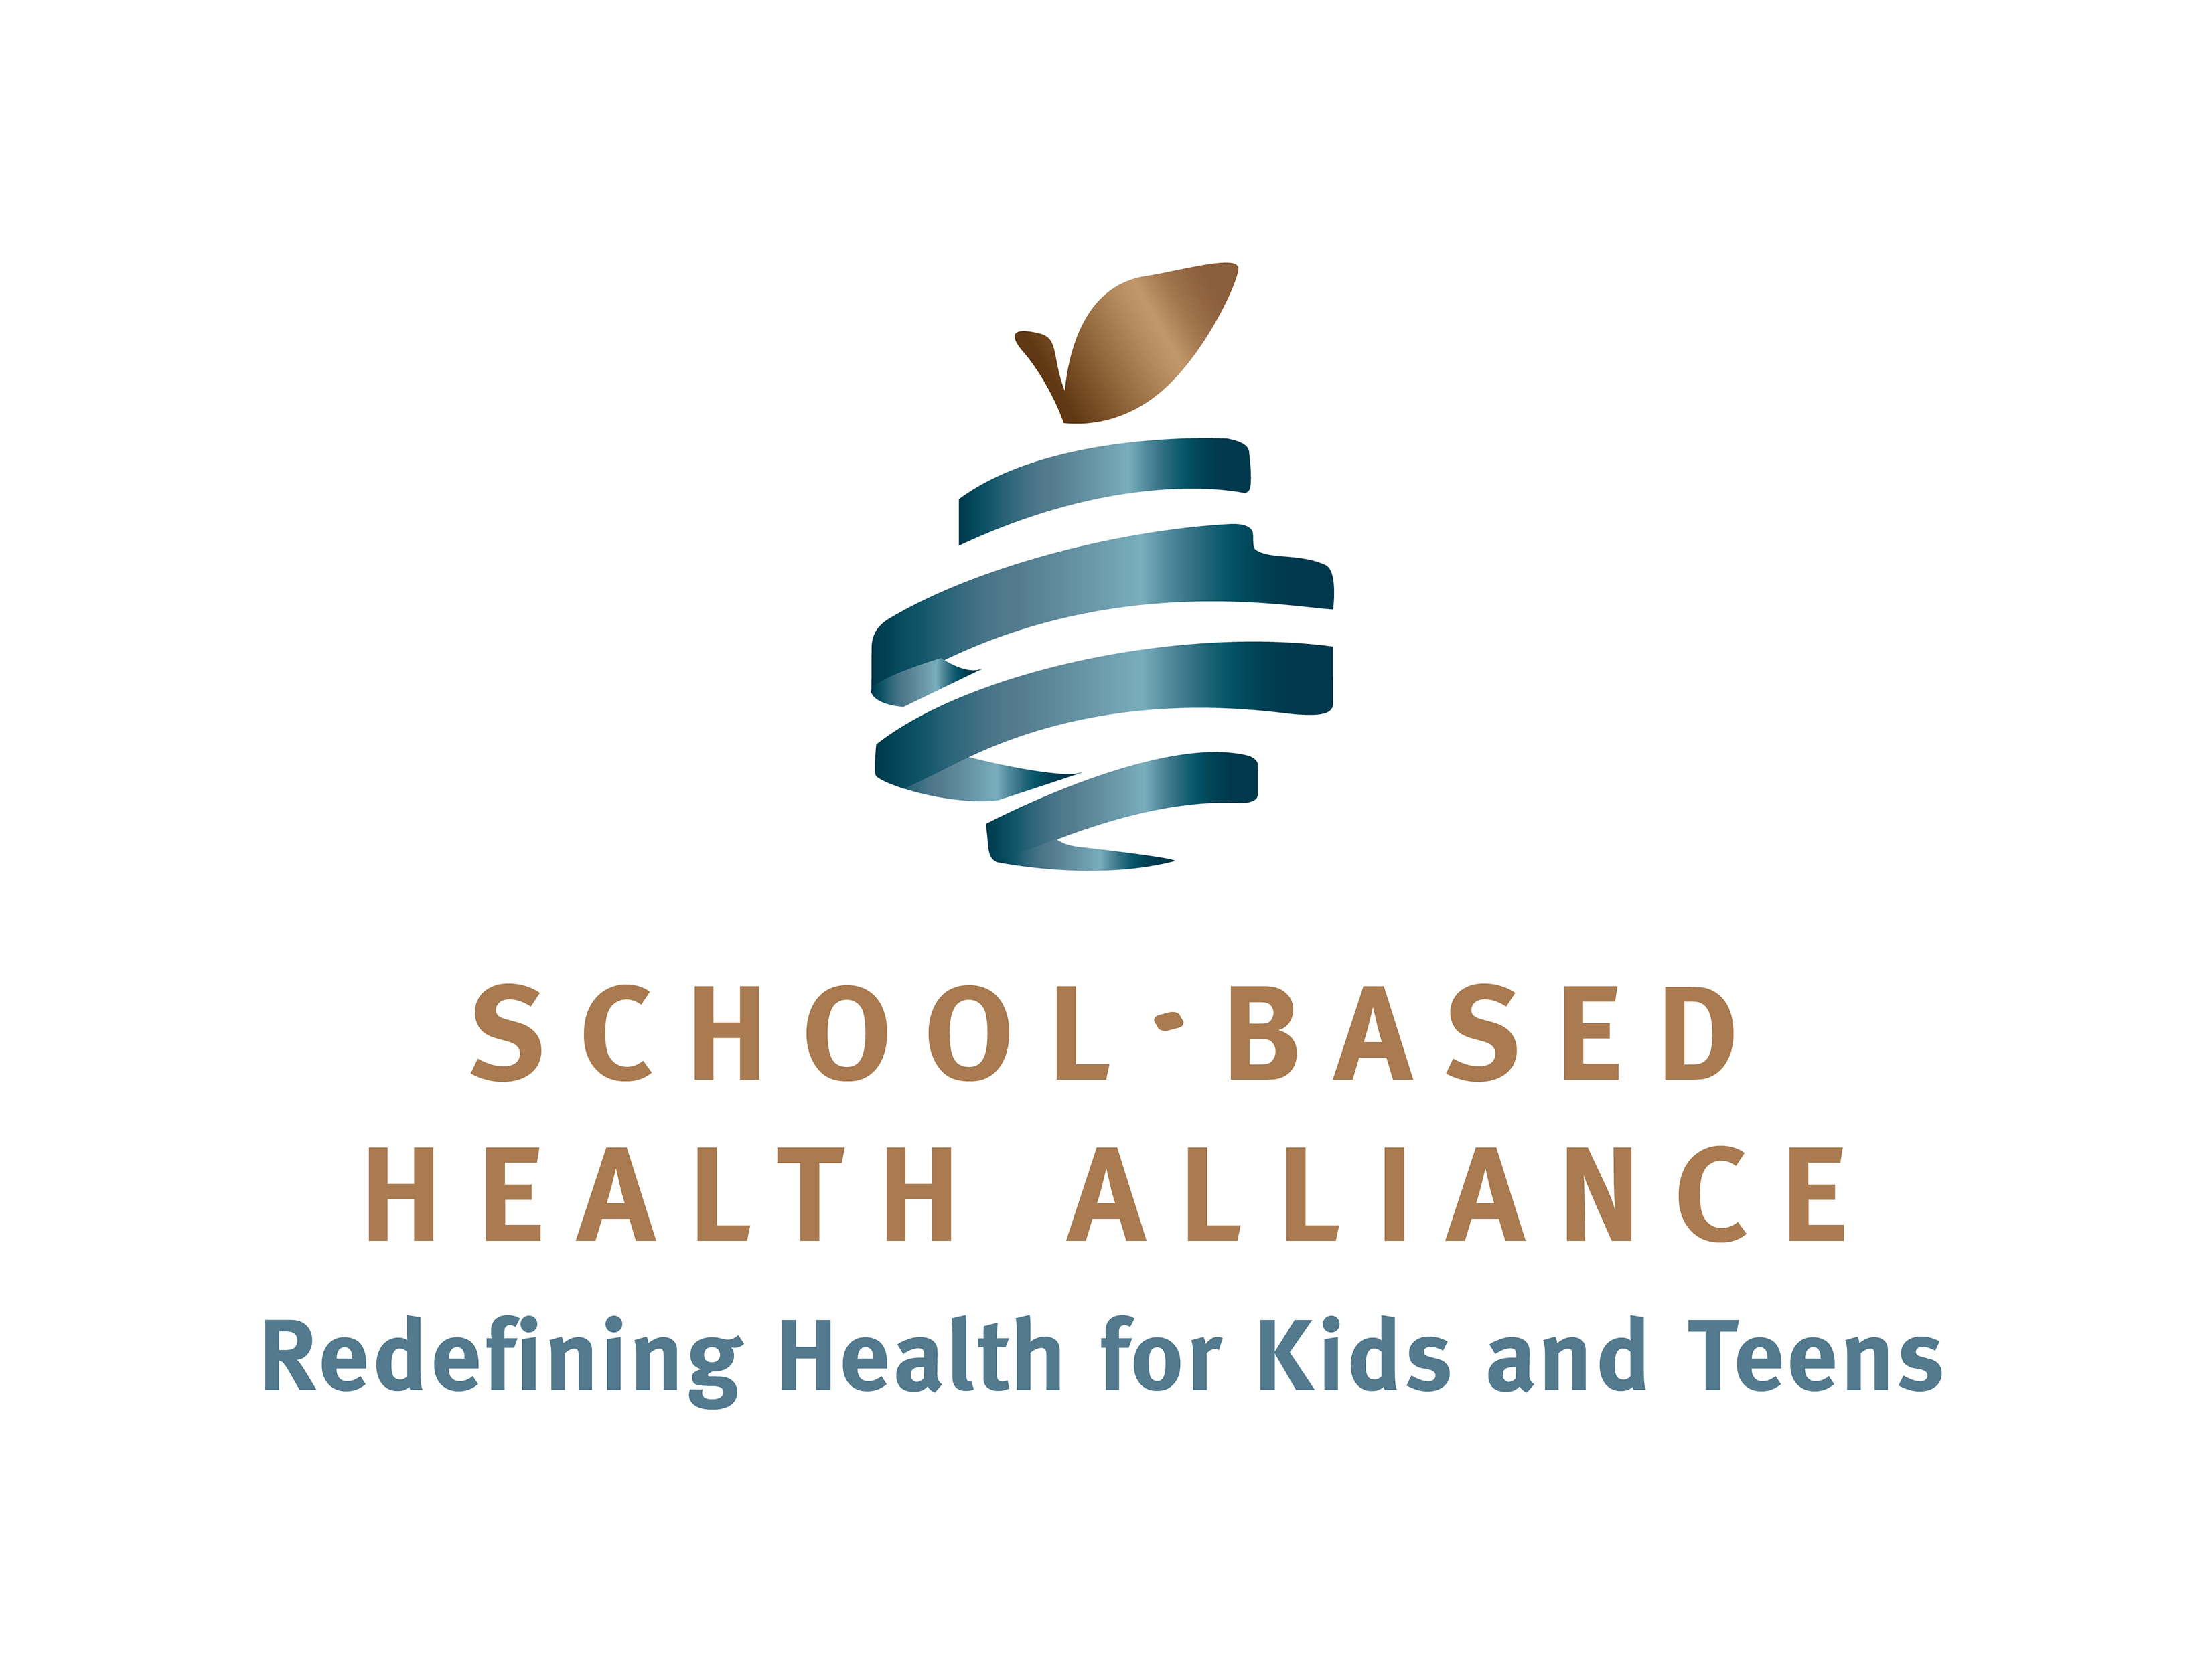

National School-Based Health Center Asthma Learning Collaborative
Application for 2016-2017
Application due on March 4, 2016 by 5:00 PM EST
Overview
Ten school-based health centers across the country will be selected to participate in a learning collaborative from April 2016-May 2017 aimed at stimulating and supporting local activities to reduce exposure to environmental asthma trigger. The collaborative will provide SBHCs with expert-led training sessions, opportunities for peer learning with other SBHC staff, and tools and resources to better support the asthma management and prevention needs of students with asthma.

Background
Regional Asthma Management and Prevention (RAMP) is a project of the Public Health Institute working to reduce the burden of asthma through a broad and comprehensive approach ranging from clinical management to environmental protection. In partnership with the California School-Based Health Alliance (CSHA), RAMP received a three-year grant from the US Environmental Protection Agency to support school-based health centers (SBHCs) in incorporating asthma environmental interventions into their services.

During the first year of the grant, RAMP and CSHA developed tools for SBHCs interested in asthma environmental interventions-- the Asthma Environmental Intervention Guide for School-Based Health Centers, which will be accompanied by trainings around the country in 2016, and four initial case studies of school-based health centers that are already addressing environmental asthma triggers. We also created a pilot learning collaborative of six school-based health centers across California. Building on lessons learned through the pilot learning collaborative, and utilizing the tools already developed, RAMP and CSHA are excited to launch the National Asthma Learning Collaborative!

Goals
The long-term goal of the National Asthma Learning Collaborative (NALC) will be to develop models for supporting students with asthma by addressing environmental asthma triggers. Long-term outcomes include:
1) Reduction in the number of asthma related emergency department visits for children and adolescents.
2) Reduction in other indicators of asthma morbidity, such as number of hospital admissions, sick visits to primary care physicians for asthma, missed school days, symptom days, and improvement in quality of life indicators.

The short and intermediate-term outcomes include:
1) Ten SBHCs will implement one new intervention to reduce environmental asthma triggers; children with asthma served by these SBHCs will experience a reduction in exposure to environmental asthma triggers.
2) Participating SBHC staff will have increased knowledge and capacity to implement asthma environmental interventions.
3) Lessons will be generated for the SBHC field on implementation of asthma environmental interventions.

Eligibility/Selection Criteria
- Ten SBHCs from across the country will be selected. The selection team will be seeking geographic diversity among the 10 participating SBHCs.
- SBHCs must be serving student populations with high asthma prevalence and/or asthma disparities.
- SBHCs should have some experience with and interest in expanding asthma interventions.
- SBHCs should be able to partner with their school administrators to implement school wide projects, as necessary.
- SBHCs must identify one SBHC staff member to participate in all meetings of the National Asthma Learning Collaborative and be responsible for all aspects of the scope of work.
- The SBHC Sponsor Agency must approve leave and travel associated with the NALC; approve all project related work described below; and provide any support (IT assistance, administrative support, leadership direction, etc.) associated with the NALC.

Scope of Work:
- Participate in a kick-off web meeting of the National Asthma Learning Collaborative on Thursday, March 31st, at 2pm EST (11am PST).
- Participate at an in-person meeting in Arlington, VA on June 29th from 12:30-4:00pm (lunch provided). SBHCs will be responsible for expenses associated with traveling to this meeting. However, we have aligned it with the School Based Health Alliance’s National Convention with the hope that participants will already be in attendance.
- Participate in 4 additional two-hour web-based meetings between August 2016-May 2017. The tentative dates are: August 24th, October 26th, February 8th, and May 17th, all at 2pm EST.
- Develop an action plan and implement one new intervention to reduce exposure to environmental asthma triggers.
- Conduct an assessment to determine the extent to which students with asthma served by the SBHC are exposed to environmental asthma triggers in their schools, homes or outdoor environment at the beginning and the end of the learning collaborative. The trigger assessment instrument will be provided by RAMP/ CSHA.
- Participate in an interview conducted by RAMP and/or CSHA at the end of the learning collaborative period, in which they will assess changes made and lessons learned. If your SBHC is successful at integrating asthma environmental interventions, we would like to develop a case study about your work. You would not be asked to write the story, but would be asked questions to guide our development of the story and would be asked to review story drafts for accuracy. We would also ask that you share photographs that may help illustrate your story. Sample case studies can be found here.

Payment:
To offset costs associated with the ALC, selected sites will receive a stipend of $3,500. The first payment ($1,750) will be received in October 2016 (mid-way through the learning collaborative year). The second payment ($1,750) will be received in May 2017 (the end of the learning collaborative period). Funding for the National Asthma Learning Collaborative has been made available with a grant from the US Environmental Protection Agency. Funding and fidelity to the National Asthma Learning Collaborative scope of work as listed above, is contingent upon continued authorization and approval from the US Environmental Protection Agency.

For more information contact: Anne Kelsey Lamb, RAMP, (510)285-5512, anne@rampasthma.org or Janine Saunders, CSHA, (510)268-1038, jsaunders@schoolhealthcenters.org

Application for participation in the National Asthma Learning Collaborative

About the SBHC
Name of SBHC:
Date SBHC established:
SBHC Address:
Name of School:
School where SBHC is based is (BOLD all that apply): | Elementary school  Middle school  High school
Enrollment at host school (#):
# SBHC patients: (This # should include all unique patients within a 1-year period)
SBHC operating hours:

About the SBHC sponsoring agency
Agency:
Type of organization (BOLD only one): | Community health center  FQHC  School district  Hospital | Non-profit organization  Other:
Chief Executive Officer: |  | Email
Chief Medical Officer: |  | Email

About the participant
Participant Name:
Title:
Years at SBHC:
Please describe your role at the SBHC in a few sentences:
Contact Email:
Contact Phone #:

About the work
Why are you interested in participating in this learning collaborative? Please limit your answer to 200 words or less

Please describe the problem of asthma and/or environmental triggers at your site. Please limit your answer to 400 words or less

Please describe any initial ideas about the types of interventions and/or types of triggers you would like to address. Please limit your answer to 400 words or less

Please describe any past or current asthma interventions and how participation in this learning collaborative will build upon that work. Please limit your answer to 400 words or less

How will your participation in this learning collaborative benefit the student population that you serve? Please limit your answer to 400 words or less

Please submit your application by March 4, 2016, 5:00 PM EST, by email to: jsaunders@schoolhealthcenters.org

