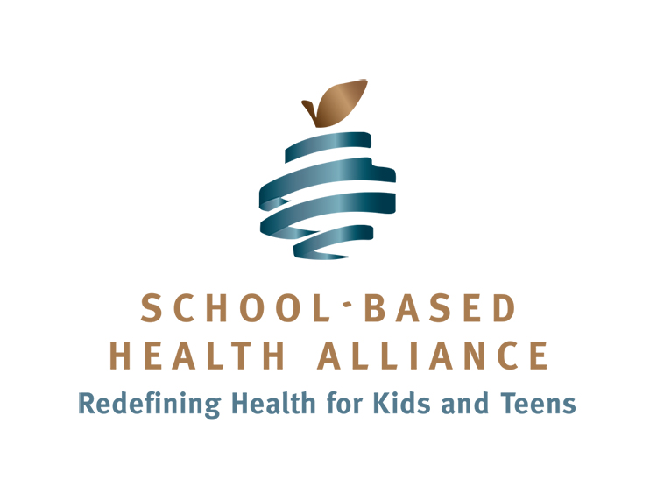

Medicaid and Health Care Reform – Questions for Federal Lawmakers

In light of the House passage of the American Health Care Act and its potential impact on the Medicaid program, we want federal lawmakers to consider the following questions about the unintended consequences of dismantling the nation’s health care safety net for our most vulnerable children and youth. We urge the U.S. Senate, in amending the House-passed language, to protect the social contract Congress made 50 years ago that assures a comprehensive health benefit for the neediest children among us. The proposed changes to Medicaid are dangerous and will be felt broadly across our human services sector and the families they serve.

We welcome the opportunity to speak with you about this information in more detail.

What consideration has been given to the impact that potential Medicaid funding cuts will have on downstream systems of care?

A reduction of any kind in the Medicaid program will likely lead to increased utilization and economic stress on other public systems. With less access to medical, behavioral, and dental care—especially preventive and early intervention services—more children and adolescents will require intensive (and costlier) remediation services from our foster care, juvenile justice, emergency and rehabilitative medicine, and special education systems. What accommodations will be made for these already over-utilized public systems under increased capacity and financial needs?

What consideration has been given to the public health impact of reducing coverage, access to services, and the number of safety net providers?

How will low-income children and youth from socially disadvantaged neighborhoods be assured cost-effective preventive services such as comprehensive exams, risk assessments, and vaccines (including the flu and HPV) if their coverage and access to care is reduced?

How will changes to the Medicaid program affect recent legislative efforts to address the opioid epidemic?

Substance abuse and addiction are on the rise. Congress has given a great deal of attention and significant resources to addressing the opioid epidemic, in particular. Comprehensive Medicaid coverage is critical to guaranteeing access to evidence-based substance abuse treatment services for both youth and adults.

How will hard working families be affected by the federal transfer of financial responsibility to states and communities?

It is likely that the burden of shifting publicly-subsidized medical costs from the federal government to the states will be felt most heavily by the very families who already experience economic hardship. Will low-income families be required to assume a larger share of their children’s medical expenses? Will cost-sharing and premium requirements (not currently applicable to school-aged Medicaid enrollees) force families to delay or forgo time-sensitive medical attention? Again, the unintended consequence of this proposal is greater stress on our least cost-effective urgent and emergent care systems.

How might proposed changes to Medicaid negatively affect the health care workforce?

Changes to the Medicaid system will certainly have economic impacts on populations other than beneficiaries. Has consideration been given to the downstream effects that current restructuring proposals will have on unemployment as health care workers lose their jobs? An economic threat to those who work within the health care safety net—community health centers, school-based health centers, etc.—is particularly real. Safety net systems rely on reimbursement from the Medicaid program for their economic stability. With a significant decrease in this form of reimbursement because of lower rates and fewer beneficiaries, many of these providers will be in jeopardy of losing their jobs. This will reduce access to care even for those who remain covered. This concern of unemployment can be expanded to other Medicaid providers as well, such as special education professionals and other school-related personnel.

Call to Action

We implore Congress to reject any changes to the Medicaid program that compromise the health, well-being and success of children—who represent less than half the enrolled Medicaid population and only 19% of total expenditures. Losing the health benefit entitlement as it is currently configured would be devastating, not only to young people as they mature and have changing medical needs, but to the tertiary systems that will have to respond to the dramatic needs brought about by the loss of early and preventive services.

About the School-Based Health Alliance

The School-Based Health Alliance is a national nonprofit advocacy organization dedicated to the notion that when schools and community-based health organizations work in partnership, all children have equal opportunity for optimal health, wellness, and dignity.

