APPENDICES

Appendix A: Sample Memorandum of Understanding 71
Appendix B: Youth Engagement Process 77
Appendix C: Job Descriptions 79
Appendix D: Guidelines for School-Based Health Centers 89
Appendix E: Sample Consent Package 97
Appendix F: Sample Customer Satisfaction Surveys 101
Appendix G: Sample Surveys 105
Appendix H: Sample Youth Focus Group Results 107
Appendix I: Sample Floor Plans 109

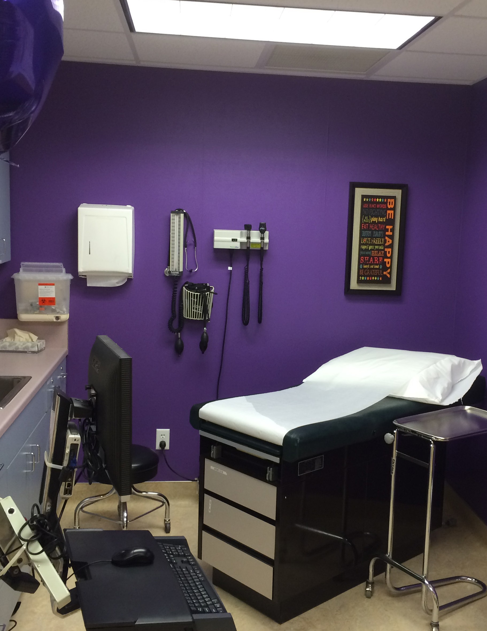

APPENDIX
A

Sample Memorandum of Understanding

INTENT
This Memorandum of Understanding (MOU) is hereby entered into by and between the Alameda Unified School District, a California public school district (hereafter “the District”) and Xanthos, Inc., a California non-profit corporation whose principal office is located at 2325 Clement Avenue, Alameda, CA 94501 (hereafter “Xanthos”). The MOU sets forth the terms and conditions by which Xanthos will provide medical, mental health, health education and other support services to
the students of Encinal, Alameda, Island and BASE schools at the Alameda High School and Encinal High School site based health centers.

AREAS OF AUTHORITY
Alameda Unified School District. The District has responsibility to provide and maintain site.
Xanthos, Inc. Xanthos shall:
  - act as Employer of Record for all on-site, Tri-High School-Based Health Center staff at each school site;
  - provide fiscal services, including processing payroll, tax payments, workers’ compensation for said employees;
  - make benefits available to its employees, including health and dental;
  - provide all necessary financial accounting and reporting services for said employees;
  - obtain an annual independent audit as part of Xanthos’ overall audit process;
  - obtain and/provide and maintain all necessary equipment and services in connection with contracting, purchasing, computer and MIS needs;
  - provide all necessary development services (including grant writing and solicitation of individual giving);
  - provide all budget services necessary to each site-based Health Center;
  - prepare and provide all necessary and/or legally required reports to funders;
  - provide overall management and leadership of site-based staff; and
  - assure and supervise the day-to day operations of each site-based program.

TERM
The term of this MOU shall be July 1, 2002 to June 30, 2003. This MOU may be extended by the mutual written agreement of both parties.

INDEMNIFICATION
Xanthos agrees to indemnify, to defend at its sole expense, to save and hold harmless AUSD, its officers, agents and employees from any and all liability in addition to any and all losses, claims, actions, lawsuits, damages, judgments of any kind whatsoever arising out of negligent acts, omissions, or intentional misconduct of Xanthos or Xanthos, employees, agents, subcontractors or volunteers in performance of services rendered pursuant to this agreement.
AUSD agrees to indemnify, to defend at its sole expense, to save and hold harmless, Xanthos, its officers, agents, and employees from any and all liability in addition to any and all losses, claims, actions, lawsuits, damages, judgments of any kind whatsoever arising out of negligent acts, omissions or intentional misconduct of AUSD or AUSD employees, agents, subcontractors or volunteers in performance of services rendered pursuant to this agreement.

INSURANCE
Xanthos shall maintain in force, at all times during the term of this agreement commercial liability and automobile liability attached hereto and made a part of this Agreement. Xanthos shall provide Worker’s Compensation insurance at Xanthos’ own cost and expense, and neither Xanthos, nor its carrier shall be entitled to recover from AUSD any costs, settlements, or expenses of Worker’s Compensation claims arising out of this Agreement.

RESPONSIBILITIES OF LEAD AGENCY, XANTHOS, INC.

In its capacity as the lead agency for the Tri-High school-based health centers, Xanthos shall provide the following services under the MOU:
- Mental Health Services
Mental Health Clinicians provide individual and group counseling, crisis intervention, and substance abuse coun- seling for students. Consultations, information, and referrals in reference to students are provided to school staff and faculty. An onsite Mental Health Clinician will provide counseling services a minimum of five days a week at Encinal and Alameda High, two mornings a week at Island High, and one morning a week at BASE High school. Services will only be rendered during the hours of operation of the school-based health center site.
- Health Education Services
A part-time Health Educator provides classroom presentations, workshops, and individual health education on a variety of health topics to students at Alameda, Encinal, Island and BASE high schools.
- Medical Services
Xanthos subcontracts with Native American Health Center to provide medical services at the two school-based clinics (AHS and EHS). In accordance with the subcontract between Xanthos and Native American Health Center (hereafter “NAHC”), NAHC shall provide the following services:
Provide a minimum of three clinics (a clinic is defined as a 4-5 hour period of time per week throughout the school year, except during those weeks when the District has closed the school for a holiday or a staff/teacher development/ planning day.) Services to be provided include: Physical exams, sports physicals, family planning, hearing and vision screening, management of chronic illnesses, screening and treatment of sexually transmitted diseases, immuniza- tions, treatment of minor illnesses and injuries, and well baby exams. Services will only be rendered during the hours of operation of the school-based health center sites (Mon. – Fri., 8:00 – 4:00).

RESPONSIBILITIES OF THE ALAMEDA UNIFIED SCHOOL DISTRICT
In its capacity as local grantee, the AUSD agrees to fulfill the following responsibilities:
- Space: AUSD will allocate sufficient space to the Tri-High School Health Services to satisfy the Bureau of Primary Care space regulations for school-based health centers, maintain confidentiality of clients who obtain health services through private exam rooms and counseling offices, and secure confidentiality of patient records through a locked safe/space.
- Facilities. AUSD will maintain the school-based health centers in a manner acceptable to Xanthos and the designated Program Director. Prior to the beginning of each school year, the Program Director will conduct a walk-through inspection of the facility to determine its readiness for school based health center operations. The walk-through will include inspection of: facility cleanliness, safety and accessibility; paint; safety; furniture; and AUSD equipment. The Clinic Supervisor will identify any problems in writing, and AUSD will attempt to remedy these problems within a reasonable period of time not to exceed 2 weeks.
- Equipment. All equipment provided by AUSD will be maintained by the district directly or through maintenance agreements with outside vendors. This includes but is not limited to:
  - Door locks, keys, other equipment related to access to schools and clinics
  - Telephones
  - T1 Lines
  - Plumbing
  - Climate control (heat/air conditioning)
  - Electrical/wiring
- Telecommunications. AUSD will provide and fund a minimum of seven (7) independent telephone lines for the exclusive use of the Encinal High school-based health center site and six (6) independent telephone lines for the exclusive use of the Alameda High school-based health center site. If the school is unable to meet this need (for confidential telephone, facsimile and Internet access), AUSD will permit the Xanthos MIS department to install additional telephone lines for the school-based health center. Any computers, whether provided by AUSD or Xanthos, will be networked and Internet-ready during regularly scheduled school operations.
- Communication. AUSD will identify one (1) liaison at the school district level and one (1) liaison at the school site.
- Contracts/Accountability. The following grid will be filled out by the school and/or school district within the first 4 weeks of the school year beginning. This list will be updated as appropriate to maintain easy access to key functions and personnel.

AREA | Responsible (Name/Title) | Phone
Security
Plumbing
Climate control (heat/air conditioning)
Electrical/wiring
Maintenance/
AUSD equipment
Incident reports
Keys/access to school and clinic
Custodial
Student contact information
Registration
Student discipline
(e.g., suspensions and expulsions)
Guidance counselors
School psychologist(s)
Telephones

- Health Clerk. School-based health center staff will work collaboratively with the Health Clerk to provide immunizations to students, identified by the Health Clerk, who need immunizations to enroll in school.
- Access to Information. School-based health center staff will be given easy access to student information (such as class schedules) needed for its functioning. Specifically, staff will be able to access the school’s most current student emergency and contact information through emergency cards and/or the school’s SASI system.
- Access to AUSD Staff. AUSD representatives will respond to requests from Tri-High School Health Services in a manner consistent to the AUSD process of response to school staff.
- Keys. AUSD will provide at least eight (8) sets of keys to SBHC personnel, each of which set will include access to the school, the SBHC and any other relevant areas (e.g., gates, locked areas within school/health center) to allow access after hours and during school breaks.
- Custodial. AUSD will maintain the cleanliness of the SBHC in accordance with OSHA standards for medical facilities. On a daily or as-needed basis determined by SBHC staff, AUSD will refill soap dispensers, paper towels and toilet paper. More comprehensive cleaning will occur on at least a biweekly basis or as needed to ensure these
standards are met. In the event that the district/school is unable to fulfill this obligation, AUSD will cover costs borne by Tri-High School Health Services to purchase outside custodial services. AUSD will then provide the cleaning crew contractors with necessary tools (e.g., keys, alarm codes) to access the SBHC after school hours.
- Safety. AUSD will ensure that each school-based health center meets state safety and fire codes.
- Policies and Procedures. AUSD and school staff will inform SBHC staff, verbally or in writing of appropriate procedures in the following situations upon request:
- Student sick or injured; no medical personnel onsite; parent/guardian not reachable.
- Emergency procedures, including fire, earthquake, violence or threat of violence on campus.
Tri-High will be informed within a reasonable amount of time of a request to modify facility (e.g., erect wall, remove furniture).
- Storage. Adequate storage will be provided for office and medical supplies, biohazardous waste disposal, and student medical records. This space will be locked and inaccessible to school staff to ensure safety and protect patient confidentiality.
- Student Access. School liaison will ensure that students who have been given an approved pass are allowed to leave class or other school activities to use the school-based health center.
- Confidentiality. AUSD will respect the client’s right to confidentiality in accordance with the Board of Behavioral Science and the American Psychological Association ethics.

BILLING AND COLLECTIONS
- Xanthos and its subcontractor will attempt to bill and collect for services provided through appropriate third party

payers (i.e. Medi-Cal, Family PACT, CHDP, etc.) All revenues generated by school-based health center staff will be retained by Xanthos to cover costs incurred by the school-based health center.
- Under the direction of the Program Director, the Administrative Assistants and Medi-Cal eligibility workers will be responsible for helping student patients apply for and enroll in appropriate health insurance coverage. All services will be provided to students free of charge

RELATIONSHIPS BETWEEN AUSD AND XANTHOS
Fundraising. AUSD and Xanthos are committed to sustaining the onsite school-based clinics at Alameda and Encinal High and mental health services/health education at all of Alameda’s public high schools. As in past, if funds in the AUSD budget become available for allocation, AUSD may provide funding to supplement Tri-High’s services. AUSD and Xanthos agree to coordinate and inform each other of any fundraising and grant writing efforts on behalf of the health center or associated programs.
Communication. AUSD and Xanthos will promote and maintain a strong and positive collaboration through open and clear verbal and written communication.
The Tri-High Program Director and other school-based health center staff will have access to students, faculty and staff for SBHC outreach activities. Alameda, Encinal, and Island High Schools will include Tri-High’s parent consent forms with new student registration mailing and other mailings as appropriate. Meetings between the Tri-High Program Director and AUSD will include the two-way identification of problem areas and a commitment to shared problem solving and accountability.
The undersigned agree to the terms and conditions of this agreement:

AUSD Superintendent Xanthos, Inc. Executive Director

Memorandum of Agreement Between
The ANY Public Health Commission and ANY Public Schools regarding
The ANY School Health Center

This Memorandum of Agreement is designed to formalize the continuing relationship between the through the ANY Public Schools, and the ANY Public Health Commission, regarding the operation of a school health center.
The parties agree to collaborate on the implementation and operation of the School Based Health Center (“SBHC”) at .
PS and PHC agree that the SBHC will occupy space rent-free at in the Health Suite Room
, where space has been renovated for the SBHC. This space will be used to provide comprehensive school-based health services to the students who are enrolled in the SBHC.

Terms of Agreement
- Public School and agree to provide the following at no cost to the Public Health Commission:
  - Space at in Health Suite Room as renovated and presently defined as shared reception area, one examination room, shared bathroom, shared clean and dirty areas, office, and storage. In addition, when possible and at the discretion of the Headmaster, the will provide space for additional counselors and/ or health educators as arranged with the Headmaster.
  - All utilities.
  - Security services: i.e. services of school safety officers as needed.
  - Routine maintenance and repairs (e.g. light bulbs, windows, ceiling tiles, towels, toilet paper).
  - Rubbish removal (Non-hazardous waste).
  - Telephone line
  - Two telephone extensions.
  - Custodial services
  - Annual alpha list of students and their class schedules, updated as necessary.
  - Immunization information on students enrolled in the SBHC at
- PHC will provide the following at no cost to PS or :
  - Comprehensive school-based health center services as defined in the consent form and in compliance with PS policies.
  - Health care equipment and supplies for use in the SBHC.
  - Proper maintenance and disposal of hazardous waste.
  - One direct phone line.
  - Computer equipment and maintenance of same.
  - Appropriate staffing for the SBHC (with training and licensing as warranted)
  - Medical supervision of staff.
  - All billing responsibilities.
  - Medical malpractice insurance for all appropriate staff.
- PHC agrees to allow the PS to list the names of the SBHC and the PHC in catalogs, brochures and correspondence as the entities operating the ANY School Based Health Center, subject to the prior approval by PHC for such use.
- PS agrees to allow PHC to list the name of the in catalogs, brochures and correspondence as the host and collaborating agency for the SBHC, subject to prior approval by PS for such use.
- PHC agrees that it has complete responsibility over the operation of the SBHC at .
- PHC agrees to serve patients under age eighteen (18) with parental consent or, alternatively, with self-consent in accordance with Massachusetts Emancipated Minor laws. Patients eighteen (18) and over may sign their own consent forms.
- PHC agrees that it will, to the extent permitted by law, protect the confidentiality of any and all information received from students who seek services at the school-based health center unless disclosure is necessary for the health and safety of the student and/or other persons.
- The SBHC and PS staff will work cooperatively. 75

- Either the PHC or PS may terminate this Agreement for any reason or without reason upon at least ninety (90) days written notice to the other party. However, if an academic semester has commenced or is within sixty (60) days of commencing, such notice of termination shall not be effective until completion of said semester. Either party may also terminate this Agreement at any time if the other party defaults in any of its material obligations hereunder, but only is such default shall have continued for a period of ten (10) days after the receipt of a written notice thereof from the other party. Further, PHC may terminate its obligations immediately and without liability, in the absence, withdrawal or termination of availability of funds from the Grantor or other external Funding Source, if any, or authorization from the Funding Source to expend grant moneys for the purposes described in this Agreement. Nothing in this paragraph shall be construed to limit or alter PHC’s responsibility to transition PS students to continuing and appropriate health services, upon termination of the PHC’s obligations under this Agreement.
- This Agreement constitutes the entire understanding and Agreement between BPHC and BPS with regard to all matters herein. This Agreement supersedes in the entirety any and all previous agreements, whether written or oral, between the parties.
- This Agreement may be amended only in writing signed by all the parties hereto.
- All notices and other communications required or desired to be given shall be given personally, or sent by telefax, registered or certified mail, postage prepaid, return receipt requested to the persons at the addresses set forth
below. Notices will be deemed received (a) on the date delivered, if delivered personally; (b) when sent by telefax (if confirmation notice is sent by registered or certified mail on the same day; or (c) three (3) business days after posting, if sent by registered or certified mail:
Public Health Commission: . Public Schools:
School Health Programs Superintendent of Schools
Public Health Commission Public Schools
Street Address Street Address
City, State, Zip City, State, Zip
The parties shall rely upon the addresses set forth above unless notified in writing of a change.
- This Agreement shall be governed by the laws of the Commonwealth of Massachusetts.
- Nothing herein shall create or be deemed to create any relationship of agency, joint venture or partnership between PHC and PS. Neither party shall have the power to bind or obligate the other in any manner except as expressly provided in this Agreement.
- The parties’ attention is called to General Laws c.268A (the Conflict of Interest Law). No party shall act in collusion with any other party, person or entity to circumvent such law.
- Neither party shall be liable to the other or be deemed to be in breach of the Agreement for any failure or delay in rendering performance arising out of causes beyond its reasonable control and without its fault or negligence. Such causes may include, but are not limited to, acts of God or the public enemy, fires, floods, epidemics, quarantine restrictions, strikes, freight embargoes or unusually severe weather.
- If any provision of this Agreement is declared or found to be illegal, unenforceable, or void, then both parties shall be relieved of all obligations under that provision. The remainder of the Agreement shall be enforced to the fullest extent permissible by law.
- Any waiver, expressed or implied, by either party of any rights, terms or conditions of the Agreement shall not operate to waive such rights, terms or conditions or any other rights, terms, or conditions beyond the specific instance of waiver.
The Parties hereby cause this instrument to be executed by their duly authorized officers.

Executive Director, Public Health Commission Date

Superintendent of Public Schools Date

Headmaster Date

APPENDIX
B

Identify project goals, objectives, scope and sequence

Youth Engagement Process

Get additional professional development/support

Assess if you’re ready to lead youth engagement process

NO YES
Develop (new) strategy & work plan for youth engagement
Adult leaders’ qualities and skills:
- Trust youth
- Good listener and facilitator
- Experience working with youth
- Help network/navigate institutions
- Respectful of youth’s views, time, experiences, diversity, culture
- Risk-taker: not afraid of challenges
- Supportive and caring
- Recognize what youth know/don’t know
- Understand boundaries
- Organized
- Won’t ask too much of youth

Youth & adult partners review plan

Recruit youth to participate

Train youth

Provide ongoing support to youth as they complete tasks
Youth leardership skills:
  - Knowledge of topic/issue
  - Cultural competency
  - Team work
  - Empathy
  - Descision-making skills
  - Goal setting skills
  - Evaluation
  - Presentation skills

Evaluate both process and product of youth engagement

77

APPENDIX
C
Job Descriptions

POSITION TITLE: DIRECTOR OF SCHOOL-BASED HEALTH SERVICES
REPORTS TO: Executive Director
FUNCTION: Coordinate all services for school based health center(s). Provide leadership for staff; act as liaison with the campus; assist in design and funding of health services for adolescents.

RESPONSIBILITIES:
- Manage comprehensive school-based health program development including maintenance and recruitment of collaborative partners.
- Serve as liaison to campus administrator and work cooperatively with the campus staff and Stockton Unified School District.
- Develop and participate in Healthy Start Programs at various schools. Provide assistance to the development of Franklin and Chavez High School Health Centers.
- Provide center management at Edison Health Center; supervise clinical staff and program at Stagg Healthy Start Center. Supervise and evaluate staff; schedule staff as needed for various services. Plan and coordinate staff training and meetings.
- Develop parent/campus/student support for CHDP and primary care; expand campus enrollment in MediCal and Healthy Families managed care.
- Assist with funding development and ensure that objectives of funding agencies are met and/or that plans are generated to meet program objectives.
- Develop budgets based on program funding in consultation with Fiscal Director.
- Ensure compliance with clinic licensing laws and contract agreements. Maintain all medical records, quality assurance data, policies, procedures and protocols in a professional manner in cooperation with the Director of Clinical Services.
- Report accurate data on a timely basis as required by billing and administrative departments. Collect regular statistics on center activities and other relevant data and submit them to appropriate persons and/or work with the evaluation team.
- Participate as a member of the Management Team for the agency.
- Represent Delta Health Care in the community at various meetings and events.
- Participate in meetings, training, or workshops as required.
- Provide case management and counseling services to students as necessary.
- Assume other duties as requested.

QUALIFICATIONS:
    - Advanced degree in Public Health, Social Work, Counseling, or Nursing preferred.
    - Minimum two years of management experience in health care setting and/or school-based services.
    - Knowledge of grant development/writing.
    - Experience working with adolescents.
    - Ability to relate to people from diverse backgrounds.
    - Energetic, organized and proficient in time management.
    - Ability to work under pressure.
    - Bilingual helpful.
    - Valid California drivers’ licence, DMV printout, and proof of automobile insurance.
    - Able to pass physical examination requirements.

POSITION TITLE: CASE MANAGER I
REPORTS TO: Director of School Based Programs
FUNCTION: With supervision from Director of School Based Programs, the Case Manager is responsible for the development, implementation and evaluation of case management activities. Provides limited lab testing and related counseling to students. Facilitates better mental and physical health in Health Center clients through appropriate and timely referrals, follow-up, and assistance.

RESPONSIBILITIES:
- Conduct case management intake interviews with individuals and develop treatment plan.
- Monitor client needs and service provision and conduct follow-up as necessary.
- Follow-up on all referrals received by administrators, teachers, and other staff.
- Provide pregnancy testing, counseling, and referral to students seeking this service.
- Provide case management to pregnant students and students participating in family planning services.
- In coordination with medical staff, provide HIV testing/counseling and Gonorrhea and Chlamydia testing (urine only) at Edison and Stagg sites.
- Assist Health Educator in the development of health education materials, and in providing special workshops and programs.
- When necessary and appropriate, work with family members in obtaining services.
- Conduct group and individual sessions on various physical and mental health issues.
- Provide client advocacy activities including coordination of in-house and referral services for medical care, emotional and practical support, public assistance, community services and mental health services.
- Prepare reports on case management activities, track statistics, and monitor outcomes.
- Maintain thorough client documentation, including obtainment of consent forms and follow proper procedures for charts and fee slips.
- Attend all staff meetings and training as required.
- Perform other duties as required.

QUALIFICATIONS:
- BS/BA degree in psychology, sociology, social work, or related field. At least three years of work experience in a related field MAY be considered in lieu of the degree requirement.
- At least one year experience in individual and/or group counseling and case management programs such as school- based health centers, mental health facilities, or other social services settings.
- Knowledge of and ability to communicate information on sensitive issues including sexuality, pregnancy, and mental health.
- One year experience working with Office of Family Planning and other state-sponsored programs such as Teen Smart, Family PACT, Medi-Cal, and Healthy Families.
- HIV testing and counseling certificates desired.
- Strong written and verbal communication skills.
- Bilingual preferred.
- Valid California driver’s license, DMV printout, and proof of automobile insurance.
- Able to pass physical exam.

POSITION TITLE: CASE MANAGEMENT ASSISTANT
REPORTS TO: Director of School Based Programs
FUNCTION: Assists families with completion of Medi-Cal and Healthy Families enrollment forms.

RESPONSIBILITIES:
- Assist case manager assigned to Stagg High School with student and family activities.
- Provide application assistance to families desiring enrollment in Healthy Families and/or Medi-Cal insurance programs.
- Assist school-based medical staff with managed care outreach and enrollment.
- Maintain daily records and documentation of activities.
- Conduct outreach to the community to promote school-based health programs.
- Attend community meetings or public events, representing the agency as required.
- Attend all required staff meetings and training.
- Perform other duties as required.

QUALIFICATIONS:
- High school graduate.
- Fluent in English and language of population served, with demonstrated communication skills.
- Experience in completion of Healthy Families and Medi-Cal Applications. Certified Application Assistor (CAA) Certificate desired.
- Knowledge of community services and resources.
- Valid California driver’s license; DMV print-out; working vehicle; evidence of automobile insurance.
- Able to pass physical examination.

POSITION TITLE: TRI-HIGH PROGRAM ASSISTANT

REPORTS TO: FUNCTION:

RESPONSIBILITIES:
- Provide clerical, administrative, and computer support to the Program Director and Health Center staff
- Answer all incoming calls
- Oversee and help organize office procedures for the Center
- Manage front office and waiting area
- Greet clients and members of the community
- Provide information and referral services
- Schedule appointments for Health Center staff
- Organize, schedule and provide clerical support to the medical clinic
- Responsible for lab work pick-up/drop-off twice a week
- Accurate and timely documentation of services and other related paperwork
- Maintain an inventory of supplies and order as needed
- Organize and file all Health Center related forms and materials
- Create and develop forms and protocols for Health Center operations
- Create and develop educational and publicity materials for Health Center services such as flyers, announcements, brochure inserts etc.
- Data entry for all Health Center services, maintain Health Center client data base system and maintain the Alameda County client data system
- Learn and maintain new software programs for the Center when needed
- Attend and participate in staff meetings and trainings as designated by the Program Director
- Other duties as assigned by Program Director

QUALIFICATIONS:
- Previous administrative, computer, and clerical experience
- Excellent organizational skills and attention to detail
- Ability to relate to youth, school district personnel, and staff
- Flexibility and ability to handle multi-tasking responsibilities
- Excellent communication and interpersonal skills
- Energy, enthusiasm, resourcefulness, and the ability and desire to initiate projects
- Ability to work independently and as part of a multi-disciplinary team;
- Multi-cultural sensitivity

POSITION TITLE: PRIMARY CARE PROVIDER
REPORTS TO: Medical Director of the ACC
FUNCTION: To provide primary care services to enrollees at the ACC in compliance with the Supervisory Agreement of Gates County Family Practice. The PCP will operate at the ACC in hours opposite to the RN for approximately 4 hrs per day when the ACC is open.

RESPONSIBILITIES:
- On-site primary and emergency care of the ACC enrollees
- Development and implementation of health and prevention programs
- Prescribing medications in accordance with license and DEA regulations
- Appropriate documentation and maintenance of health records
- Compliance with CLIA and OSHA requirements
- Compliance with ACC standards as regarding Health Checks
- Assuring ACC facility is maintained and appropriately stocked for service provision
- Corresponding with parents/guardians as to the care of the child
- Monthly contributions to public service announcements from the ACC
- Supervision of the “Future Health Professionals of America” club at Gates County High School

QUALIFICATIONS:
- Graduation from an accredited PA or NP program.
- Current Licensure in the state of North Carolina
- Current DEA certification or willingness to obtain such certification
- Current certification by appropriate credentialing body (NCCPA)
- Understanding of the unique functions of a School-Based Health Center.

POSITION TITLE: REGISTERED NURSE
REPORTS TO: Direct ACC supervision of this role will rest with the PCP. Ultimate supervision and assurance of all qualifications and certifications is the responsibility the Nursing Supervisor of Hertford-Gates District Health Department
FUNCTION: To provide nursing services to enrollees at the ACC in compliance with the NC State Personnel Description “Public Health Nurse II.” The RN will operate at the ACC in hours opposite to the primary care provider for approximately 4 hrs per day when the ACC is open.

RESPONSIBILITIES:
- On-site primary and emergency care of the ACC enrollees within the scope of practice of an RN and in compliance with agreed upon nursing protocols.
- Development and implementation of health and prevention programs
- Coordination and performance of Health Check physical exams
- Appropriate documentation and maintenance of health records
- Compliance with CLIA and OSHA requirements
- Coordination of the ACC immunization program
- Assuring ACC facility is maintained and appropriately stocked for service provision
- Corresponding with parents/guardians as to the care of the child
- Monthly contributions to public service announcements from the ACC

POSITION TITLE: NUTRITIONIST
REPORTS TO: Direct ACC supervision of this role will rest with the PCP. Ultimate supervision and assurance of all qualifications and certifications is the responsibility the Health Director of Hertford-Gates District Health Department.
FUNCTION: To provide nutrition services to enrollees at the ACC in compliance with the NC State Personnel Description “Nutritionist III.” The nutritionist will operate at the ACC for approximately 7.5 hrs per week and be available for extended service to parents and faculties on a prn basis.

RESPONSIBILITIES:
- Provision of medical nutrition therapy to students.
- Maintenance of appropriate nutrition data in patient record
- Collaboration with all other ACC services in the provision of care
- Provision of nutrition education using age appropriate language, written materials and audio and visual resources.
- Maintenance and ordering of needed nutrition materials with the approval of the ACC Program Director.
- Planning and supervision of nutrition programs during National Nutrition Month
- Monthly contributions to public service announcements from the ACC

POSITION TITLE: HEALTH EDUCATOR
REPORTS TO: Direct ACC supervision of this role will rest with the PCP. Ultimate supervision and assurance of all qualifications and certifications is the responsibility the Health Director of Hertford-Gates District Health Department..
FUNCTION: To provide health education services to enrollees at the ACC in compliance with the NC State Personnel Description “Health Educator.” The health educator will operate at the ACC for approximately 7.5 hrs per week and be available for extended service to parents and faculties on an as needed basis.

RESPONSIBILITIES:
- Developing and implementing a wellness program for students
- Providing health education and health promotion to ACC enrollees
- Provide group Health Education for parents and faculties
- Maintenance of appropriate health education data in patient record
- Collaboration with all other ACC services in the provision of care
- Participate in grant writing
- Share responsibility with the PCP in sponsoring the “Future Health Professionals of America” club at Gates County High School
- Maintenance and ordering of needed health education and other promotional materials with the approval of the ACC Program Director.
- Monthly contributions to public service announcements from the ACC

POSITION TITLE: MENTAL HEALTH WORKER/LCSW

REPORTS TO:
FUNCTION: This is a half-time hourly position that provides mental health services for adolescents at the Adolescent care Center, ACC. The position will provide basic mental health screening and support services on-site at the ACC.

RESPONSIBILITIES:
- Addictions counseling (for alcohol, drugs, co-dependent relationships)
- Anger management
- Anticipatory Guidance
- Behavior modification/ Self esteem enhancement
- Case management
- Community resource planning (linking patients to financial help in community)
- Counseling for grief and loss
- Counseling for victims of abuse and neglect
- Crisis intervention
- Eating disorders counseling
- Emotional support and encouragement
- Parenting skills
- Problem solving/guidance for life’s decisions
- Psychosocial assessments/screenings (mental health screenings for depression)
- Psychotherapy
- Stress management

QUALIFICATIONS:
- Masters Degree in social work from an accredited university approved by the Council on Social Work.
- Provider must have either a North Carolina clinical license in social work (LCSW) or a provisional North Carolina clinical license in social work (LCSW-P) and access to a supervisor who has a North Carolina clinical license in social work.

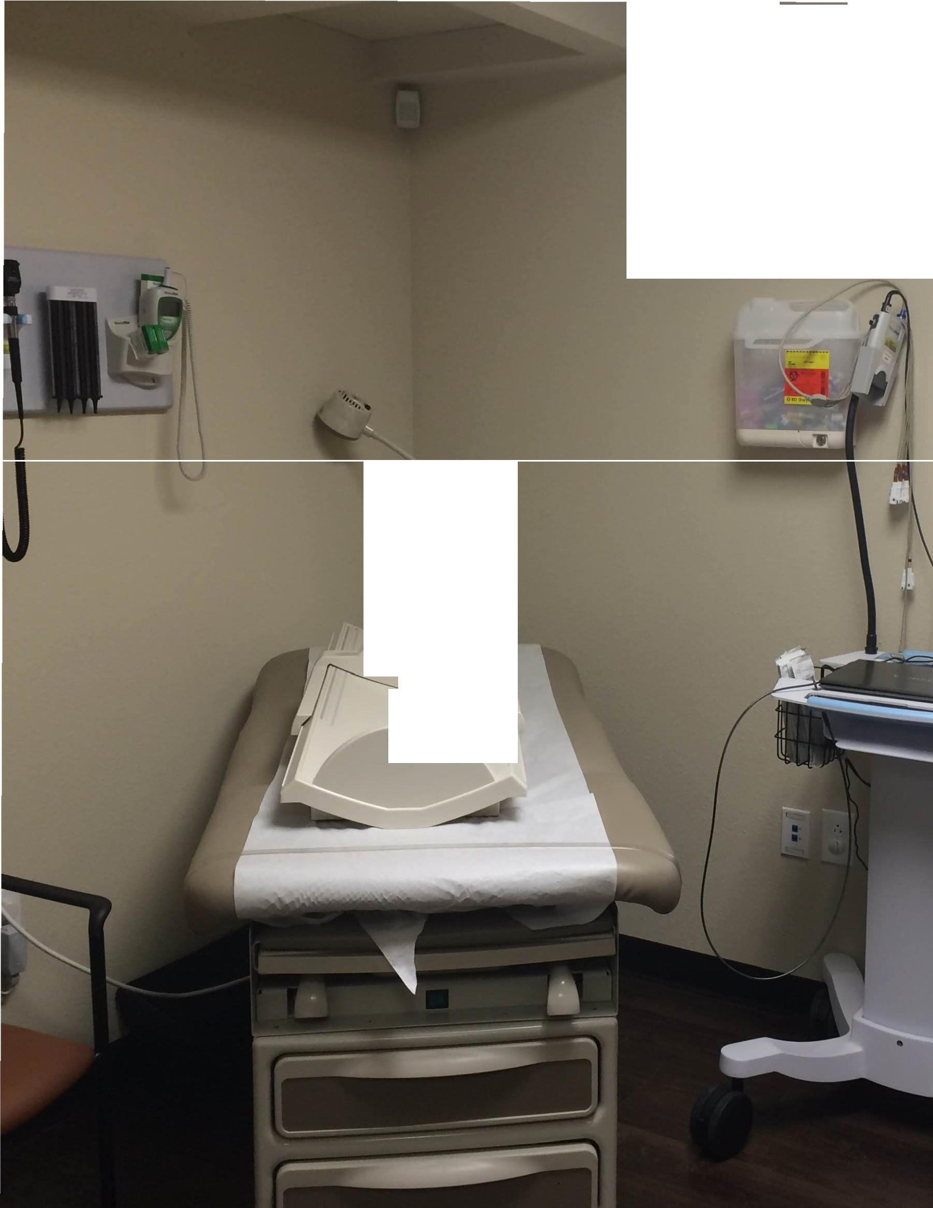

/"
.
-

.

APPENDIX
D

Guidelines for School- Based Health Centers

DEFINITION
A school-based health center is a facility that delivers one or more of the following clinical service components on a school campus or in an easily accessible alternate location including a mobile health van stationed on or near a school campus.
School-based health centers in California may provide one or more of the following clinical service areas:
  - Medical services
  - Behavioral health services
  - Oral health services
School-based health centers may be open as full-time or part-time sites.
  - Full-time sites should be open during all normal school hours with at least one staff person present. (Clinical services are not necessarily available during all of these hours.)
  - Part-time sites are open limited hours as dictated by need or resources.

PURPOSE OF SCHOOL-BASED HEALTH CENTERS
Research has shown that school-based health centers provide an effective means for students to access comprehensive health care, mental health services, health education, prevention services, oral health and social services. Parents/guardians find that school-based health centers are an accessible and reliable source of care for their children that ensure their child’s health needs are being met and that keep the child in school.
There is a strong relationship between academic achievement and a child’s physical, emotional and mental health. School-based health centers in California are designed to serve the following purposes:
  - increase access to medical, dental and behavioral health services
  - support schools in improving academic outcomes
  - contribute to public health goals related to disease prevention and control.
California’s school-based health centers are located in high-risk communities, communities that are medically underserved, and/or in areas with few health care professionals.

GENERAL GUIDELINES IN ALL THREE CLINICAL SERVICE CATEGORIES
Administration
  - Every school-based health center should have a lead agency that has overall responsibility for school-based health center administration, operations and oversight. The lead agency is usually the fiscal agent for the health center and employs the center director/manager. The lead agency may or may not be the clinical services provider.
  - There should be an identified staff person responsible for the school-based health center’s overall management, quality of care, and coordination with school personnel.

Facilities
  - All school-based health centers, regardless of the service components offered, should be housed in a facility, whether stationary or mobile, that is easily identifiable by students, families, and school staff. The facility should include at least one confidential treatment space appropriate to services provided, as well as an additional area for patient and family reception, enrollment, and triage.

Staff
  - All staff should have appropriate health credentials to practice, including active certification or current licensure, as appropriate to their position. Additionally, all staff shall maintain their licensure through appropriate professional standards.

Confidentiality and Privacy Protection
  - School-based health centers should ensure confidentiality in the sharing of medical information under state and federal laws including HIPAA, FERPA, and Minor Consent as defined by California law. The health center should annually inform (in writing) enrolled students and their parents/guardians of their rights and responsibilities regarding:
    - confidentiality
    - privacy
    - safety and security
    - informed consent
    - release of information
    - financial responsibility
    - minor consent laws and sensitive services in California

School Integration
  - School-based health center services are developed based on local assessment of needs and resources.
  - Parents, students (at the high school level), school staff and community members are engaged in the development, oversight, and/or provision of school-based health center services.
  - School-based health centers provide services in keeping with district policies.
  - There should be a written, formalized relationship between the school or school district and health providers. This may be a written contract, memorandum of understanding, or statement of agreement between the school district and all outside service providers that comprise the health center describing the relationship between the district and the provider(s), or between the school district and the lead agency for the health center, which should then have its own written agreement with other providers. The contract or agreement should be active (not expired); the term/length of the agreement should be decided by both parties involved; the agreement may define a process for reviewing what is working/not working during the “life” of the agreement.
  - School-based health centers should either convene or participate in a school-wide health/wellness collaborative. This collaborative should include members from all providers (district, school-based health center, and community) of health or wellness services to the school community. They may use a model such as the CDC’s coordinated school health program to drive the integration of comprehensive school-based health programs. If the school does not have such a collaborative, the school-based health center is responsible for forming and convening it at least twice a year. Distributed/shared leadership models are recommended.
  - School-based health centers develop policies/protocols to coordinate care, ensure continuity of care, and facilitate case management in partnership with the school and other service providers. School personnel include credentialed school nurses, health assistants, administrators, teachers, counselors, and support personnel. One process for this coordination may be through the school’s Student Success Team.

  - There should be a process for referring students/families to the health center that is understood and approved by school staff and administrators. The referral process should facilitate access to care as opposed to relying on the student/family to initiate contact with the health center. Mechanisms for facilitating access could include: walking the student/family to the health center, assisting with scheduling an appointment, initiating contact from the health center by calling students out of class or calling families at home (while protecting student confidentiality).
  - There should be coordination between the health center and the school nurse or health assistant (if applicable) including delineation of roles and responsibilities (especially for state-mandated health services in the absence of a school nurse), protocols defining permissions related to sharing of medical information (e.g. immunization records, serious medical conditions), procedures for service coordination, and reviewing how it is going and adjustments needed.

Prevention Programs
  - The school-based health center should have a role in school-wide health education and outreach, school-based public health programs, youth development programs, or family support programs. Activities may include: classroom presentations, table/presentation at school functions, lunch time activities, posters or displays on campus, presentations to school staff, participation in wellness policy councils or other health committees, and nutrition
and fitness promotion programs. Full-time centers should participate in/offer at least two school health-promoting activities/year. Part-time centers should participate in/offer at least one school health-promoting activity/year.
  - Unlicensed staff that provides health education, youth development, and/or family support services should be trained in basic health promotion, public health, and/or community engagement principles. A CHES (certified health education specialist) is preferred, though not required.

Health Insurance Outreach and Enrollment
  - All school-based health centers should take steps to ascertain student insurance coverage, health plan, and primary care provider (if applicable) with the goal of obtaining this information for all students seen at the health center. The health center should facilitate student enrollment in health insurance programs such as Medi-Cal, Healthy Families or other local coverage options.

Billing Capacity
  - The health center shall bill CHDP, Medi-Cal, Healthy Families, health plans and/or other third party payers as appropriate based on the lead agency, community and services provided.

Access to Care
  - Fees. The center serves all students in the school regardless of insurance status or ability to pay. No student can be denied services because of inability to pay. The center may also serve siblings, parents or other community members and may develop its own policies regarding fees and accessibility of services for these populations.
  - Hours. The health center shall be open during hours accessible to its target population, and provisions should be in place for the same services to be delivered during times when the center is not open. These provisions shall be posted, given to and/or explained to clients including at a minimum an answering service/machine message. The health center shall have a written plan for after-hours and weekend care, which shall be posted, given to, and/or explained to clients.
  - Transportation. If the health center is not on school grounds, there is a mechanism to facilitate transportation from the school to the health center, or to ensure a safe pedestrian corridor to/from the health center, if necessary. This mechanism will be publicized appropriately with clients and families.
  - Non-discrimination. Students shall not be denied access to services based on race, color, national origin, religion, immigration status, sexual orientation, gender identity, disability, handicap or gender.
  - Language. Reasonable accommodation shall be made to provide language/translation services to non-English speaking and deaf students.

Quality Improvement
  - Adherence to relevant standards of care adopted by national professional organizations – American Academy of Pediatrics, Society for Adolescent Medicine, American Dental Association, etc.
  - Gathering of feedback from both clients and school stakeholders through annual needs/resource assessments and age-appropriate client satisfaction surveys as well as satisfaction surveys with parents and school staff. Focus groups or a “comments box” can also be used for this purpose.
  - Process for reviewing patient/school feedback and adjusting practice as needed.

Advisory Committee
  - School-based health centers should maintain a local advisory committee that meets at least two times per year. The committee membership should include at least two representatives from the school staff, parents, and students (if middle or high school). The committee should also include two health care providers outside the school-based health center (e.g., community-based primary care providers, hospitals, community clinics), public agencies
(e.g., local health department, county office of education, probation, county mental health department), and local community-based organizations. The function of the committee is to:
    - Provide input on school or community issues related to student health.
    - Make recommendations for the type of services that the school-based health center should start, continue, expand or discontinue.
    - Make recommendations for policies and procedures at the school-based health center.
    - Develop an annual summary of school-based health center work and recommendations that will be made public (e.g. to school board, school leadership team)
* The advisory committee is not meant to usurp the authority of an existing FQHC advisory board and may function as a subcommittee or workgroup of a larger advisory board.

Data Collection
  - Certain data variables shall be collected at each encounter or visit including:
    - Unique patient identifier (not name)
    - Date of birth
    - Gender
    - Ethnicity/Race
    - Insurance status
    - Date of visit
    - Location of visit (site identification)
    - Provider type
    - CPT visit code(s) (for MediCal providers only)
    - Diagnostic code(s) (ICD-9 or 10)
    - Selected risk factor status
    - For managed care counties: Visit time units

GUIDELINES FOR SCHOOL MEDICAL SERVICES
Minimum Services
  - Well child or adolescent exams, consisting of a comprehensive health history, complete physical assessment, screening procedures, and age-appropriate anticipatory guidance
  - Episodic acute care including diagnosis and treatment of illness and injury
  - Immunizations
  - Basic laboratory tests including urinalysis and hemoglobin
  - Follow-up and coordination of care for identified illnesses or conditions
  - Assessment and education related to nutrition, fitness, and oral health (may be provided by nonclinical, unlicensed staff)
  - Chronic disease management:
    - Assist primary care providers and school nurses in the day-to-day management of student chronic illness.
    - Respond to emergency exacerbations of chronic illness with nebulized treatments for severe asthma, glucagon injections for severe hypoglycemia, and epipen administration for anaphylactic reactions.
  - If serving an adolescent population, and approved by local school board:
    - Conduct psychosocial/risk assessment
    - Offer pregnancy tests and counseling as appropriate
    - Offer tests and treatment for sexually transmitted infections as clinically indicated
  - Referrals for specialty care or other needed services not provided onsite

Recommended Services
  - Comprehensive health education/promotion outside of the clinical setting
  - Nutrition services, such as nutrition counseling, healthy habits support, family education, healthy cooking/shopping classes
  - Developmentally appropriate, culturally competent reproductive health care, including:
    - Contraceptive counseling and dispense or prescribe contraceptives and emergency contraception
    - Diagnosis and treatment for sexually transmitted infections (as above) plus HIV testing and counseling
    - Gynecological examinations and cancer screening if indicated
    - Treatment or referral for prenatal and postpartum care

Licensing
  - School-based health centers with a community health center or hospital serving as the medical services provider must be licensed by the California Department of Public Health as an independent clinic, affiliate clinic, satellite clinic, or mobile van of the community health center or hospital. District-run school-based health centers are waived from this licensing requirement by the state.
  - School medical service provider agencies, whether a community health center, hospital, or school district, must be certified as CHDP and/or Medi-Cal providers.
  - Stationary, school-based health center facilities must pass school fire and safety clearance.
  - The school-based health center is in compliance with OSHA rules regarding occupational exposure to blood borne pathogens.
  - The school-based health center is in compliance with the Clinical Laboratory Improvement Amendments of 1988 (CLIA) regulations for the type of laboratory tests being performed on site.

Staff
  - The school-based health center shall be staffed during all hours of clinic operation by a certified nurse practitioner (FNP, PNP, or SNP), licensed physician, or a licensed physician assistant working under the supervision of a physician. The nurse practitioner must be a licensed RN, and certified or eligible for certification in California. The physician and physician assistant must be licensed to practice in California.

  - Some licensed professional staff may work remotely via a telehealth system, so long as appropriate support staff is on- site to facilitate the telehealth assessment or treatment.

Coordination with Primary Care Providers
  - The school-based health center should develop procedures for communicating with the primary care providers (PCPs) of the clients for whom the school-based health center is not serving as the PCP. These procedures are necessary to promote continuity of care, facilitate provider collaboration, assure appropriate utilization of health resources, and ensure appropriate protection of confidentiality.
  - When a student’s PCP and/or health plan are identified, the PCP and/or health plan should be notified every time the patient/member receives a prescription for a new medication or adjustment of existing medication.
  - It is also strongly recommended, though at the clinician’s discretion, to also notify the PCP when the patient/member receives:
    - a well-child/adolescent examination
    - immunizations
    - diagnosis of an acute condition that requires follow-up
    - recurring episodes related to a chronic condition.

GUIDELINES FOR SCHOOL BEHAVIORAL SERVICES
Minimum Services
  - Age-appropriate, culturally competent screening and assessment to facilitate early identification of substance abuse, domestic/dating violence, and mental health disorders
  - Client education on mental health and substance abuse prevention/awareness
  - Individual, family and/or group therapy/counseling provided by an appropriate staff person (see Staff section below)
  - Crisis intervention/counseling
  - Case management/client advocacy
  - Referrals to a continuum of mental health services, including for medications, emergency psychiatric care, community support programs, substance abuse services, and inpatient and outpatient mental health programs

Recommended Services
  - Collateral contact such as consultation with school administrators, parents, teachers and students
  - Home visits
  - Alcohol, drug, and tobacco abuse education or cessation/treatment
  - Family support services and referrals, such as counseling or parenting education
  - Follow-up procedures for referrals
  - School faculty education, such as in-service training, on mental health conditions’ signs and symptoms
  - School-wide mental health promotion, such as stress management or suicide prevention
  - Violence prevention, education and intervention

Staff
  - School behavioral health services should be provided by:
- a licensed mental health professional,
- a registered (though not yet licensed) mental health professional, or
- an unlicensed mental health intern or trainee under clinical supervision by a licensed mental health professional. Clinical supervision must be provided as defined by the Board of Behavioral Science Examiners.
While registered mental health professionals may receive clinical supervision from an off-site licensed supervisor, in- terns and trainees should have on-site supervision of their services. These may include psychologists, social workers, psychiatrists, psychiatric/mental health nurses, and licensed professional counselors.
  - Non-clinical services such as discussion groups, classroom education on mental health or substance abuse, non- clinical collateral contacts, or assistance with referral and follow-up may be provided by unlicensed, unregistered support staff who have received professional development in health education, youth development, or non-clinical support services.
  - Some licensed professional staff may work remotely via a telehealth system, so long as appropriate support staff is on- site to facilitate the telehealth assessment or treatment.

GUIDELINES FOR SCHOOL ORAL HEALTH SERVICES
Minimum Services
  - Oral health screenings
  - Fluoride varnish
  - Sealants
  - Dental cleanings
  - Oral health education
  - Referrals to local dental treatment and specialty services off-site

Recommended Services
  - Basic restorative services
  - Follow-up procedures for referrals

Staff
  - Services may be provided by a licensed dentist and/or hygienist, depending on level of service.
  - Some licensed professional staff may work remotely via a telehealth system, so long as appropriate support staff is on- site to facilitate the telehealth assessment or treatment.

APPENDIX
E

Sample Consent Package

PROGRAM DESCRIPTION
Chappell Hayes Health Center at McClymonds High School
A School-based Satellite Center of CHILDREN’S HOSPITAL AND RESEARCH CENTER AT OAKLAND
The Chappell Hayes Health Center at McClymonds High School provides a variety of services for adolescents, including the following:
Medical Services (i.e. comprehensive physical exams; management of acute and chronic illnesses; sport, college and employment physicals; vision and hearing services; reproductive health services; immunizations; first aid and triage; emergency medical response),
Counseling and Therapy (i.e. individual, family and group counseling; psychiatric assessment and medication man- agement; crisis counseling; anger and stress management; depression and anxiety counseling; relationship counseling; drug and alcohol counseling; body image and eating disorders counseling; behavioral, narrative and solution focused therapy)
Youth Development* (i.e. Peer Health Education internships; FACES health careers internships; Youth Leadership Council; Youth Sounds Media Arts; YELL! Youth Research and Advocacy; Adventure Academy Wilderness Ex- cursions) *Please note that these programs have separate admissions criteria and are not covered by the following conditions and Program Description.
Health Education (i.e. healthy life style counseling including nutrition and exercise; substance abuse and tobacco prevention services; HIV/STD prevention and counseling; conflict resolution services; family planning; peer health education; human sexuality support groups and counseling)

CONFIDENTIALITY:
Participation in any of the health centers’ services involves the collection of personal information. As required by law and by our payors, we keep written progress and treatment records. Your written records will be handled as confidentially as possible within the law. Please note that most insurance companies and third party payors, including Alameda County Behavioral Health, do require that providers share information with them about our patients’ assessment, diagnosis and treatment. All written materials and videotapes will be stored in locked files in the Health Center.
We often videotape our sessions for the purpose of providing better care, if you give consent. You will be asked to sign a separate consent form for any videotaping that might be done.
In our department we work as a team, consisting of medical doctors, nurses, interns, post-doctoral fellows, psychiatrists, marriage and family therapists, social workers and psychologists. Information about you, your family and your child may be shared with other members of the team, or other providers at Children’s Hospital Oakland if we believe that such a consultation will assist in your child’s treatment. All information is kept confidential by Children’s Hospital staff. If you wish for us to communicate about your child’s treatment with physicians, school personnel or other persons outside the hospital, we will ask you for a signed consent.
During supervision meetings, all clinicians review their work with clinical supervisors. The purpose of these meetings is to have an opportunity to review their treatment approach and ensure the quality of their work. Our clinical supervisors hold information shared in these meetings in confidence.

LIMITS OF CONFIDENTIALITY:
If previously unreported incidents of child abuse or imminent physical injury to self or others come out during the course of our work with the adolescent or family, they will need to be reported to Children’s Protective Services and/or the police, as required by law. If this would ever be necessary, we will discuss this with you, if at all possible, prior to making the report.
According to California law there are three additional areas that are exceptions to confidentiality. They are:
  - If you are seriously considering harming yourself, we are required to take whatever steps are necessary to keep you safe.
  - If you state that you are seriously considering harming another person, we are required to notify that person and the police.
  - We are required to report abuse of a person over 65 or a dependent adult.

POTENTIAL RISKS OF TREATMENT:
Psychotherapy is a process that requires time and commitment. Sometimes the process of exploring and resolving problems can cause emotional distress or increase the client’s negative behaviors for a period of time. In some cases, treatment may be ineffective, or in rare cases can cause disruptions in your life. Consistent participation, family involvement, and adequate length of treatment are central to effective therapy.
Because of the personal nature of psychotherapy and mental health care, some of the questions that you may be asked in the course of treatment may make you feel uncomfortable and you are free to decline to answer questions, stop any discussions at any time, or decide to provide the requested information at some later date. However, we will be most effective if we can develop a trusting relationship in which information is freely shared.
There are also risks associated with the use of psychiatric medications. If your child is prescribed medication through our department, the psychiatrist will discuss with you the potential risks and benefits.

FREEDOM OF CHOICE:
PARTICIPATION IN ANY OF OUR SERVICES IS VOLUNTARY. You are free to decline to participate in our program, or to withdraw from it at any point. Your decision as to whether or not to participate will have no influence on your present or future status as a client at the Chappell Hayes Health Center or any other Children’s Hospital Oakland programs.
You have the right to request and receive information at any time about fees and methods of payment, your therapist’s qualifications and education, cancellation policies, the goals of therapy, your child’s progress and type of treatment. If at any time you continue to have any questions or concerns about the quality of care you are receiving at the Heatlh Center, please feel free to contact Alex Briscoe, Health Center Director, at (510) 813-2525.
You have a right to refuse any services for yourself or for your family. If you prefer to receive services from other professionals or agencies in the community, we can assist you with referrals.

ATTENDANCE & CANCELLATION POLICY:
In most cases our counseling services require your weekly attendance for therapy sessions. If for some reason you are unable to meet during your schedule appointment with a clinician, please inform the staff member as early as possible. Other programs and internships may have specific attendance policies that will be explained at intake.

TREATMENT BY INTERNS, ASSOCIATE CLINICAL SOCIAL WORKERS AND POST-DOCTORAL FELLOWS:
Chappell Hayes Health Center is part of Children’s Hospital Oakland, a teaching institution, and some of the therapy work in the department is provided by unlicensed individuals who are supervised by senior licensed staff while they complete their training. If your therapist is a trainee, they will conduct their practice under the direct supervision of a licensed therapist.
The primary supervisor is responsible for the client’s treatment. Please feel free to contact the Alex Briscoe, Health Center Director, at 813-2525 if you have any questions or concerns about your work with your therapist.

CHAPPELL HAYES HEALTH CENTER --- PROGRAM DESCRIPTION CHECKLIST

Child’s Name

Child’s Date of Birth / / Child’s Social Security Number

I have received a copy of the Patient Bill of Rights.
(initials)

I have received Patient CHRCO Notice of Privacy Practices.
(initials)
If not received, please explain:

Services to be provided by the Health Center have been described to me.
(initials)

I understand and agree to the confidentiality agreement outlined in the Program Description.
(initials)

I have been informed that acceptance of and participation in this program is voluntary and shall not be considered a prerequisite for accessing other community services. Further, I retain the right to access other reimbursable services and have the right to request a change of provider. While the program will attempt to provide every reasonable accommodation, it cannot guarantee that request for change in clinician or staff person will be granted.

(initials)

I have received a copy of the Alameda County Behavioral Health Care Services Consumers Complaints Resolution/Grievance Information.

(initials)

Date Parent or Guardian

Date Parent or Guardian

Date Witness

APPENDIX
F

Sample Customer Satisfaction Surveys

PARENT SATISFACTION SURVEY
Dear Parent/Guardian, Date
The School Health Center is conducting an evaluation of our services to your son or daughter. We are interested in your opinions about our services.
Your participation in this survey is voluntary. All your answers will remain private and no one other than the administration of the health center will see your survey.
Thank you for your participation. We appreciate you sharing your thoughts about your child’s health care.

If your child has been to the Wellness Center, please answer the following questions.
- What services did your child receive at the Center? (Check all that applies)
o Illness (flu, cold, stomach ache or something more  serious) | o Information for parents about your child or health care  in general
o Chronic health problem (asthma, depression, headaches) | o Yearly physical or sports physical
o Vision or hearing exam | o Treatment of injury or accident
o Immunizations (vaccines) | o Care for girls with menstrual problems
o Dental exam | o Pregnancy test
o Acne or skin problem | o Services for pregnant teens
o Nutrition counseling | o Counseling for personal or emotional problems.
o Drug/alcohol prevention | o 0ther, please tell us:
o Counseling for substance abuse (tobacco, alcohol, drugs)

- How much do you think your student was helped by the Center?
o A great deal o Somewhat o Very little o Not at all o Don’t know
- Did you feel that the staff was courteous to you? o Yes o No o Don’t know, I never met the staff
- Did the staff at the Center explain your child’s medicine or treatment clearly?
o Yes o No o My child did not receive medicine or treatment
- Did the staff at the Center refer you to other services not provided by the Wellness Center?
o Yes o No o Don’t know

6. How would you rate the following aspects of the Center? Communication with parents | Excellent  o | Good  o | Fair  o | Poor  o | Don’t know  o
Appearance of the clinic | o | o | o | o | o
Convenience of the location | o | o | o | o | o
Hours that it is open | o | o | o | o | o
Quality of medical care received | o | o | o | o | o
7. Do you agree or disagree with the following? |  | Agree | No opinion |  | Disagree
a. The Center encourages students to be more responsible for their health. |  | o | o |  | o
b. Students miss less school because of the Center. |  | o | o |  | o
c. The care at the Center is confidential (private). |  | o | o |  | o
d. The Center has saved you a trip to the doctor, the school or the hospital. |  | o | o |  | o
e. The Center is a valuable service to the school community. |  | o | o |  | o
8. Are there any services that you would like the Center to provide?
o Yes o No o Yes If yes, please describe:

THANK YOU

STUDENT SATISFACTION QUESTIONNAIRE (HIGH SCHOOL)

Grade level Date | o Male | o Female
Is this your first visit to the health center this year?  If no, how many times have you visited the health center? | o Yes  o 0-1 | o No  o 2-5 | o >5
It is very important to us to know how you feel about the services you received today. Your answers to the following questions help us know how we are doing and how to improve our services.

During my visit…
- The clinic staff was courteous and friendly to me. o Yes o No o Don’t Know
Comments
- The health care provider answered all of my questions. o Yes o No o Don’t Know
Comments
- My privacy was respected. o Yes o No o Don’t Know
Comments
- I waited too long to be seen by the health care provider. o Yes o No o Don’t Know
Comments
- Did you receive medication or a prescription? o Yes o No o Don’t Know
If yes please answer #6.
- The health care provider explained to me why I needed the medicine and how to take it, using words I understood.
o Yes o No o Don’t Know
Comments
- Would you recommend the health center to your friends? o Yes o No o Don’t Know
Comments

- Could you have gone somewhere else in your community to receive the same type of service provided here at the school health center? o Yes o No o Don’t Know
- Why do you like to come to the health center at your school? (Check all that apply)
  - I like its location o I don’t have insurance o I don’t want people to know about my medical care
  - Its free (no cost to me) o I trust the staff o Other

- What other information or services would you like available in the health center?

Thank you for completing the questionnaire.

STUDENT SATISFACTION QUESTIONNAIRE (MIDDLE SCHOOL)

Grade level Date | o Male | o Female
Is this your first visit to the health center this year?  If no, how many times have you visited the health center? | o Yes  o 0-1 | o No  o 2-5 | o >5
It is very important to us to know how you feel about the services you received today. Your answers to the following questions help us know how we are doing and how to improve our services.

During my visit.....
- I waited too long to be seen by the health care provider. o Yes o No o Don’t Know
Comments
- The health center staff was friendly to me. o Yes o No o Don’t Know
Comments
- The health care provider answered all of my questions. o Yes o No o Don’t Know
Comments
- My privacy was respected. o Yes o No o Don’t Know
Comments
- I received the services I wanted toay. o Yes o No o Don’t Know
Comments
- Would you recomment the health center to your friends? o Yes o No o Don’t Know
Comments
- Were you satisfied with the health center? o Yes o No o Don’t Know
Comments

- Please tell us about any improvements you would like to see, or things you do not like.

Thanks………You’re Awesome!!

SAMPLE SCHOOL STAFF/TEACHER SURVEY

Date

We are evaluating our role at your school in providing health care services to the students. We are very aware of your commitment to the students and how hard you work at your school and are concerned about your perception regarding the availability of our services, which include the physical health and mental health of the students. We want to communicate more effectively with you, so that services are not duplicated and we can better serve the students.

Please take a moment to fill out this questionnaire and return it to the health clinic or put it in the school nurse’s mailbox.
- Have you ever referred a student to the School Health Center o Yes o No o Don’t Know about services Comments

- If yes, did you receive any feedback stating the student was seen? o Yes o No
Comments

- Do you know that providers are available to discuss issues regarding students with you? o Yes o No
Comments

- Would you like the school health center staff to do a presentation in your class next year? o Yes o No

If yes, name of teacher Extension

- Do you know the difference between the School Nurse and the School Health Center? o Yes o No
Comments

- Do you have additional suggestions for us?

APPENDIX
G
Sample Surveys

SAMPLE TEACHER SURVEY
Dear Teacher and/or Staff Member,
Provide brief background on health center and purpose of survey.

On a scale of 1-5 (1 being major, 5 being minor) rate each of the physical health problems listed below for children in your classroom.

  - Headaches
  - Sore throat or strep throat
  - Colds/fever
  - Often being really tired
  - Ear aches or infections
  - Injuries or accidents
  - Tooth aches or dental problems
  - Stomach aches
  - Skin problems or rashes
  - Diarrhea or vomiting
  - Problems with eating or weight
  - Bedwetting

We would like your perception on chronic health conditions. Please rate each of the problems listed below on a scale of 1-5 (being major, 5 being minor) for children in your classroom.

  - Asthma
  - Diabetes
  - Allergies
  - Behavior problems
  - Emotional problems
  - Seizures
  - Other:

Please comment on anything you think we need to keep in mind as we plan for the School Health Center:
Services

Hours

Prevention

Other

SAMPLE PARENT SURVEY
Dear Parent:
Adams County School District #50, The Children’s Hospital, the Colorado University School of Nursing, and Adams Community Mental Health Center are thinking about opening a School Health Center. Children attending the Early Childhood Center (ECC) and their brothers and sisters (birth through grade 5) would be eligible to receive services at the School Health Center. Services might include immunizations, physical exams, care of minor illnesses (ear aches, sore throats, cuts and bruises) and related family support services. The cost of services would be based on a sliding-fee scale, and no one would be refused service because of inability to pay.
To help us plan for the School Health Center, we would like to ask a few questions about the health needs of your child. This information will help us decide what types of services and programs to offer at the Center. Your answers are completely confidential. You do not need to put your name anywhere on this form. Thank you for your help

What physical health problems or needs has your child had in the past month? Check all that apply.
  - Headaches o Tooth aches or dental problems
  - Sore throat or strep throat o Stomach aches
  - Colds/fever o Skin problems or rashes
  - Often being really tired o Diarrhea or vomiting
  - Ear aches or infections o Problems with eating or weight
  - Injuries or accidents o Bedwetting

Have you been told by a doctor that your child has any of the following chronic health problems?
  - Asthma o Seizures
  - Attention deficit or hyperactivity o Allergies
  - Diabetes o Other

Where do you regularly take your child for healthcare? Check all that apply.
  - Family doctor or clinic o Regular source of healthcare
  - Emergency room o Other

Do you have a regular source of dental care for your child? o Yes o No
- Do you have someone you could go to for counseling services for behavioral problems?
(e.g., unusual or extreme fears, depression, nervousness) o Yes o No

How do you currently pay for health services?
  - Private insurance or belong to an HMO o No insurance and generally pay out-of-pocket
  - Medicaid or social security o Other
  - Armed Services medical plans

If we opened a School Health Center, how likely would you be to take your child there for service? Check one.
  - Would definitely use the Center o Would probably use the Center
  - Would probably not use the Center o Would definitely not use the Center

At what hours would you be most likely to use the clinic? Check all that apply.
  - Before school o Saturdays
  - During school o Immediately after school
  - Evenings

THANK YOU!

APPENDIX
H

Sample Youth Focus Group Results

The following focus group results provide an example of another type of needs assessment or evaluation tool. It is also a useful
example of youth-led research. The following recommendations came from a series of youth-led focus groups conducted in seven California communities.1

Forum Participants’ Suggestions for School Health Centers
Youth Recommendation #1: Advertise School Clinic Services More Broadly
Many students did not know what services their clinic offered nor its hours of operation. Some did not know their high school even had a health clinic. Forum participants suggested the following ideas for promoting school health centers:
- Advertise the clinic on the loud speaker at school.
- Tell people about the clinic when they first come to the school.
- Make presentations in class and explain what happens when a student visits the clinic
- Hold assemblies and rallies to introduce the clinic and staff.
- Promote the “FREE” aspect of school healthcare.
- Let students know that having a school clinic means their parents don’t have to miss work to take them to the doctor.
- Build a website for each school clinic.
While the majority of students said their parents support school health centers, students believe that some parents oppose them because they worry about their children getting health services without their parents’ knowledge. The students suggested that school clinics should develop a special advertising effort for parents and the community about the benefits to having a school clinic.

Youth Recommendation #2: Continue To Strive To Be Teen-Friendly
Youth cited fear as a barrier to seeking healthcare at the school clinics. They all agreed that clinics should be welcoming, not intimidating. Youth made the following observations:
- Employing teens or young workers in the health center would help reduce the intimidation of an adult-only staff. (This suggestion came out in every youth forum.)
- The clinic’s outside appearance should not be “scary-looking.”
- Music, television, music videos or video games will help students relax while waiting.
- The clinic should be roomy and colorful.
- School health centers should consider providing drinks and food.
Many youth also said they would not want to miss class to go to the health center; they suggested keeping clinics open every day of the week and during after-school hours. The youth seemed to believe that if clinics increased their availability and continued to work toward providing a teen-friendly environment, students would be likely to go there for help.

Youth Recommendation #3: Focus On Services That Are Important To Teens
Youth agreed that first and foremost clinics should provide general health services, but they also recommended that clinics provide more specialized health services, such as:
- Physical therapy for people to recover from injuries
- An athletic/ fitness trainer
- Counseling for family problems and psychological problems such as depression
- Health counseling to help students maintain good diets
- Sexual health services and education materials

1 Study coordinated by California Center for Civic Participation and Youth Development

Youth Recommendation #4: Emphasize Confidentiality
Above all, students wanted absolute assurance that their privacy was protected when they visit the school clinic. They suggested promoting the clinic’s privacy policy, including the details about how information is protected. The types of details they wanted included:
- Whether clinic files are locked
- Whether parents or teachers are notified if a student visits the clinic
- What type of employee policies the clinic staff – including youth staff members – must adhere to regarding student privacy
- Whether clinic records and files use students names (versus student ID numbers or other ways to track student health data)

Additional Findings: Mental Health
Most students reported that school clinics that provide mental health services were very helpful but that students did not use these services as much as they should, in some cases because they were not aware of them. Others thought talking to a counselor carried a stigma that teens would want to avoid. Recommendations listed earlier in this document regarding teen- friendliness and confidentiality might eliminate barriers to teens seeing mental health services.

Health Coverage
The majority of youth agreed that, when they did not use the school health center, the cost of healthcare was the largest barrier to getting care. Another top barrier was location/transportation (because parents have to miss work). Most students reported having to miss class to visit a doctor. Some said missing class for healthcare reasons made it difficult to make up coursework, but the bigger problem was for their parents who had to miss work to take them to the doctor.

APPENDIX
I
Sample Floor Plans

The floor plans that follow demonstrate different ways that schools may utilize existing space or create new space to house
their school health centers.

SILVER CITY, NM SBHC FLOOR PLAN
(SBHC converted from two large classrooms.)

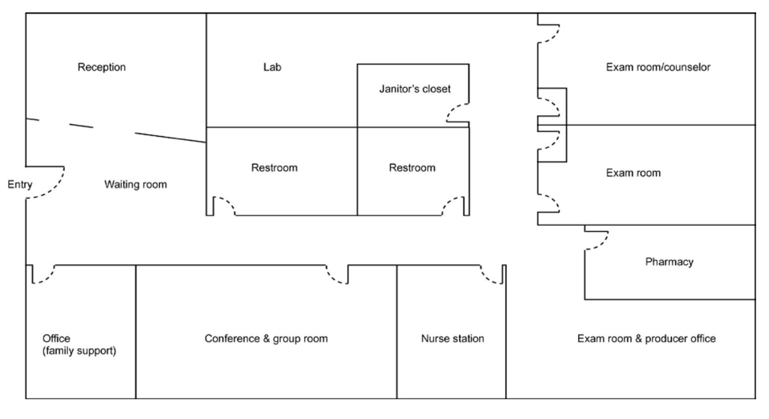

BELEN HIGH SCHOOL SBHC FLOOR PLAN
(Space created by converting a large school nurse’s office and bumping out the north and west exterior walls to add exam rooms and offices)

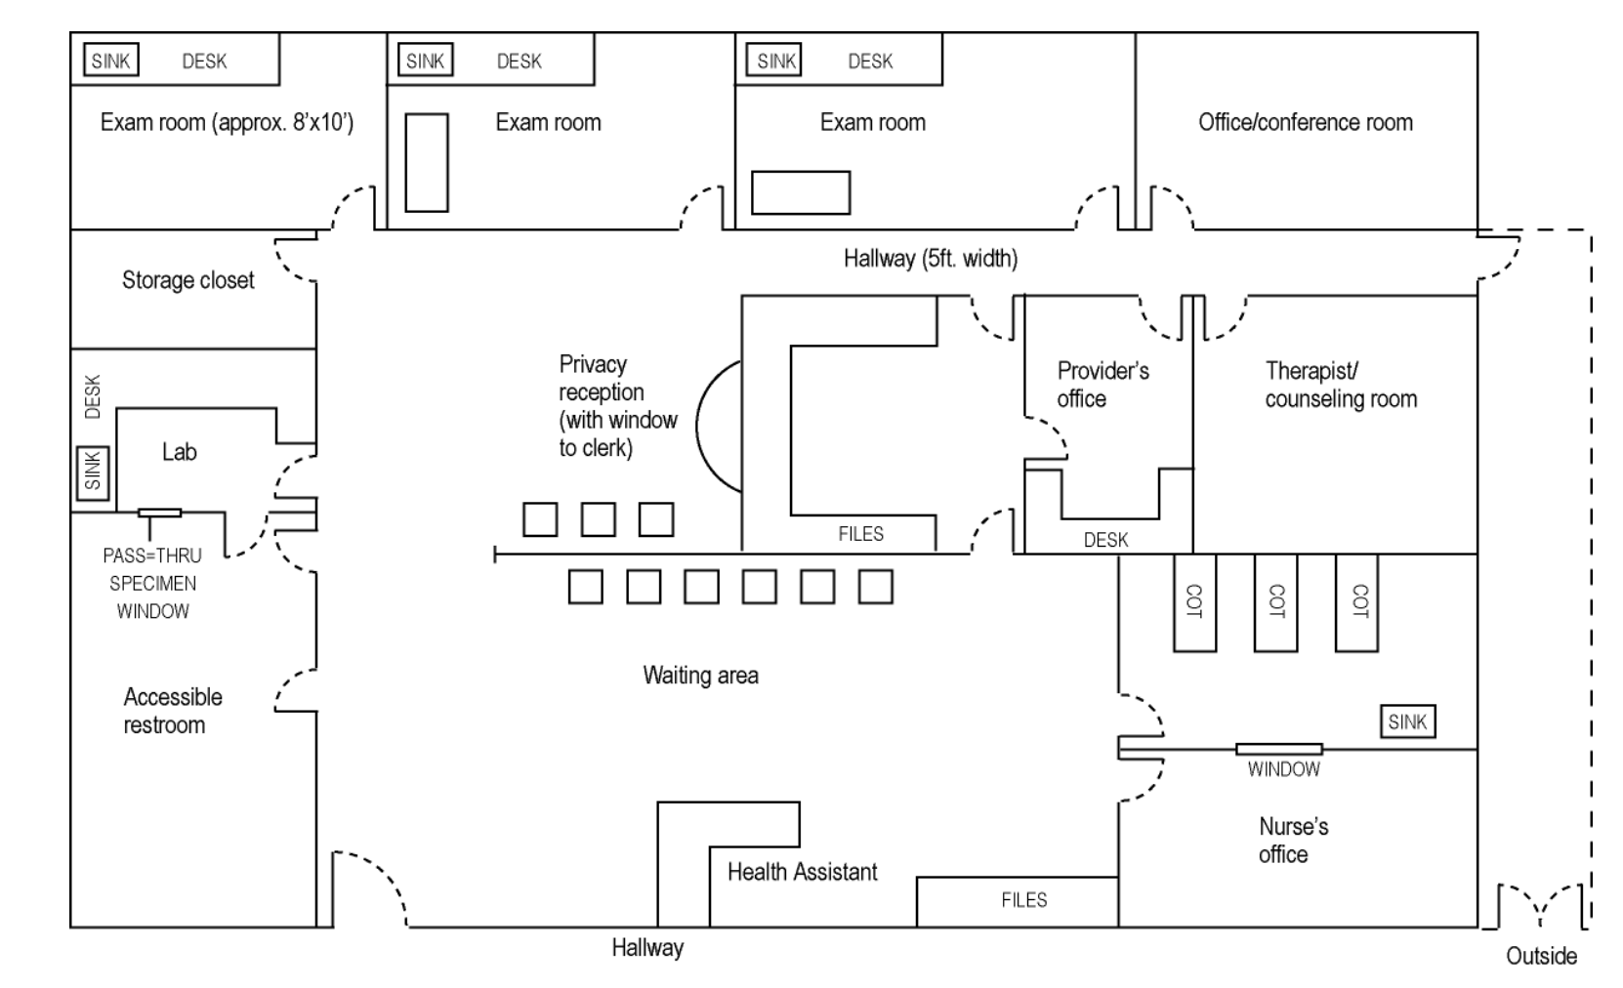

HYPOTHETICAL FLOOR PLAN FOR A FREE-STANDING SBHC

