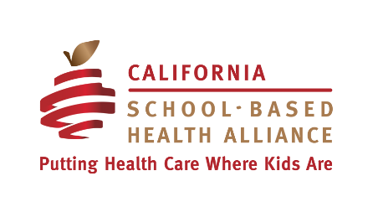
School-Based Health Centers &
California’s Community Schools

Every Community School should have a school-based health center
José Muñoz, Director, Coalition for Community Schools

SBHCs are Aligned with Community Schools
California’s school-based health center (SBHC) model is a strong complementary asset to the goals and vision for community schools in the state. SBHCs are a way for community schools to bring reliable, affordable, quality healthcare services to students and their families in an accessible and coordinated way. One of the stated goals of community schools is to “improve student outcomes by addressing students’ academic, cognitive, physical, mental, and social-emotional needs.”

Currently, California has 293 school-based health centers. SBHCs have been around since the 1970s and are health clinics on or near school campuses where children and youth can get immediate help for acute and chronic conditions as well as preventative care. These centers provide critical healthcare services to students in primarily low-income public schools and many are able to serve students’ families, school staff, and/or other community members. Services provided by SBHCs include: medical, mental health, dental, reproductive health, vision and youth engagement, as well as interventions that address social determinants of health and facilitate a positive school climate. SBHCs bring trusted adult health care professionals onto school campuses that can benefit from their caring, expertise and connections.
SBHCs are highly aligned with the Community Schools Framework and should be highlighted as a core strategy for addressing key pillars of the model.
- SBHCs address the five outlined student needs in the Community Schools Framework
- SBHCs create a site in a community school where school and community resources can be organized together and co-located
- SBHCs allow for the community school to provide wrap-around services and care to students to help close the achievement gap and break down physical and mental health barriers to learning
- Having support for basic needs allows students to participate fully in their education
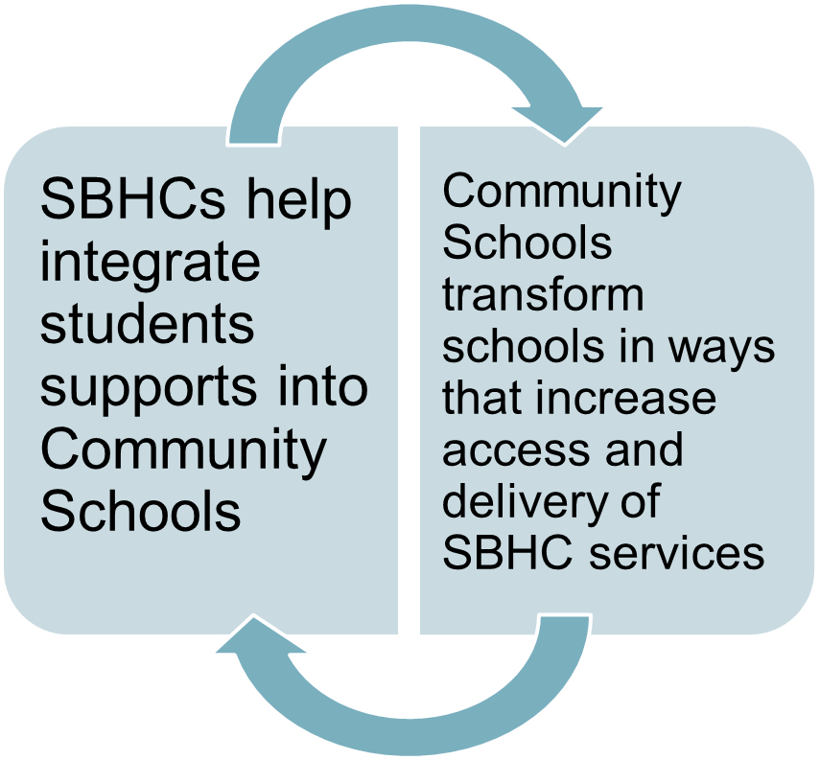
SBHCs & Community Schools Work Together
School-Based Health Centers: Trusted Lifelines in a Time of Crisis, by Curtiss Sarikey, describes how the SBHCs in Oakland Unified schools are a foundational component of the district’s full-service community schools strategy:
Our SBHC staff have developed a rare institutional trust with students, families, and community members, which is essential for providing care. During shelter-in-place, our SBHCs and health partners have been able to lean into these existing relationships with our students and families… The bottom line is that SBHCs provide essential health care in Oakland’s most high-need neighborhoods.

About the California School-Based Health Alliance
The California School-Based Health Alliance is the statewide non-profit organization dedicated to improving the health & academic success of children and youth by advancing health services in schools. While we are the go-to experts in California for SBHCs, much of our expertise is translatable to other school health models.

We provide training and technical assistance to advance school-based health services through:
- virtual and in-person statewide trainings (such as our annual conference and regular webinars);
- regional workgroups and convenings;
- one-on-one consultation, coaching, and supports; and
- written materials like toolkits and reports.

Leveraging CSHA’s Subject Matter Expertise
Through our internal expertise and network of subject matter experts, CSHA can provide relevant, high-quality trainings in a variety of formats (i.e. in-person, webinars, conferences) and resources about how schools can leverage the Community Schools model to increase access to school health services and SBHCs. Below is a sample of training topics, including some of our existing tools and resources:

- SBHC start-up and operations including how to develop partnership coordination between school districts and community providers, how to finance and sustain SBHCs, and how to integrate SBHCs and school health services into school communities to improve student attendance and school climate, and support student success.
  - From Vision to Reality: How to Build a School Health Center from the Ground Up
  - Multiple resources for SBHC Operations

- Student health confidentiality and data sharing including information sharing practices and laws across schools and health care in California (HIPAA-FERPA).
  - A California Guide for Sharing Student Health and Education Information

- Trauma-informed and healing-centered schools and health services including how to implement and expand mental health services in LEAs and through SBHCs, how to train and support school staff on trauma-informed and healing-centered practices (i.e. restorative practices, culturally-sensitive ACEs/trauma screening), and how to build staff wellness programs.
  - Practices to Increase Healing & Trauma-Informed Services at SBHCs
  - California Student Mental Health Implementation Guide

- Youth Engagement including training for adult allies and school staff on how to engage youth in health advocacy, peer-to-peer supports, and leadership, and school-based health advocacy for youth leaders, including alternatives to punitive practices.
  - Virtual Youth Engagement Strategies from California School-Based Health Centers
  - Youth Health Worker & Learn, Meet, Practice Curricula

- Sustainability including how to leverage Medi-Cal and other public funding sources to sustain health services.
  - Funding for SBHCs (webpage with multiple resources)
  - Funding for School-Based Mental Health (webpage with multiple resources)

